Inequality of Opportunity of Daycare and Preschool Services in Brazil*
Miguel N. Foguel♦
Fernando Veloso♣
Resumo
Nesse trabalho medimos o grau de desigualdade de oportunidade de acesso à creche e à pré-escola no Brasil utilizando um índice de oportunidade que modifica o índice de oportunidade humano recentemente proposto na literatura e empregado em Barros et al. (2009) para medir a desigualdade de acesso a oportunidades básicas na América Latina e Caribe. Utilizando dados de um questionário suplementar das PNADs de 2004 e 2006, construímos uma medida de oportunidade que inclui não somente o acesso, mas também a decisão voluntária da família de não matricular as crianças na creche ou pré-escola. Os resultados mostram grandes diferenças entre a nossa medida e o índice de oportunidade humana para as crianças de 0 a 3 anos e diferenças bem menores para as crianças entre 4 e 6 anos, o que sugere que a pré-escola pode ser considerada mais perto de uma oportunidade básica do que a creche. Mostramos também que as oportunidades cresceram tanto para a creche quanto para a pré-escola entre 2004 e 2006. Entretanto, as oportunidades são expressivamente maiores para a pré-escola do que para a creche, mesmo levando-se em consideração que a não-freqüência da criança pode ser uma decisão voluntária da família e não necessariamente um indicador de falta de oportunidade.
Abstract
In this paper we measure the degree of inequality of opportunity of access of children to daycare and preschool services in Brazil using an opportunity index that modifies the human opportunity index proposed in the literature and used in Barros et al. (2009) to measure inequality in the access to basic opportunities in Latin America and the Caribbean. Using data from a supplementary questionnaire that was included in the 2004 and 2006 versions of PNAD, the main Brazilian household survey, we construct an opportunity measure that includes not only attendance but also the voluntary option not to enroll children in daycare or preschool. The results show that there are large differences between our opportunity index and the human opportunity index for children aged 0-3 years old and considerably smaller differences for children aged 4-6 years old, which suggests that preschool may be closer to a basic opportunity than daycare. Moreover, we show that opportunity increased in Brazil for both daycare and preschool services between 2004 and 2006. However, opportunity is considerably higher for preschool than for daycare, even after taking into account the fact that non-attendance may be a voluntary decision and not necessarily an indicator of lack of opportunity.

Palavras-chave: Oportunidade, Desigualdade, Infância, Educação.
Keywords: Opportunity, Inequality, Childhood, Education.
JEL: D39, D63, I21
Área ANPEC: Economia Social e Demografia Econômica (Área 11)

1. Introduction
A large body of literature makes the case for investment in early childhood development (ECD). Research in neuroscience has established that learning is easier in early childhood than later in life (see a discussion of the evidence in Cunha et al., 2006 and Cunha and Heckman, 2009). Other studies have argued that the returns to human capital investment in early childhood are higher than later in life because the beneficiaries have a longer time to reap the benefits (Becker, 1993). Carneiro and Heckman (2003) also argue that investments in human capital have dynamic complementarities, in the sense that earlier investments increase the returns to later investment. They also claim that there is no tradeoff between equity and efficiency in early childhood investments, whereas for later investments an increase in efficiency is usually associated with more inequality.
This evidence suggests that ECD interventions and, in particular, daycare and preschool have potentially high returns. Consistent with this evidence, in many countries, and in Brazil in particular, policymakers have been increasing investments in ECD programs. Moreover, since the late eighties, several changes in the Brazilian legislation related to daycare and preschool have been enacted. A consistent pattern behind these changes is that they reflect a continuous increase in the importance attached by legislators to the provision of daycare and preschool services in Brazil.
For instance, the Constitution of 1988 established that all children aged between 0 and 6 years old have the right to free public daycare and preschool services. In 1996 it was approved in Congress the Lei de Diretrizes e Bases da Educação (LDB), a law that established the organizational principles governing the provision of education services in Brazil. One important aspect of this law is that it stated that the level of Basic Education in Brazil should include not only primary school, but also daycare, preschool and secondary school. Even though only primary education was mandatory, the inclusion of preprimary education (as well as the secondary level) indicated that the provision of access to early childhood education was viewed as an educational priority.
Consistent with the inclusion of preprimary education in the level of Basic Education, in 2007 the Fundo de Manutenção e Desenvolvimento da Educação Básica e de Valorização dos Profissionais da Educação (FUNDEB) replaced the Fundo de Manutenção e Desenvolvimento do Ensino Fundamental e de Valorização do Magistério (FUNDEF) as the most important source of funding for primary and secondary education in Brazil. One important innovation of FUNDEB is that it included preschool and daycare, thus becoming a potentially important source of funds for pre-primary expenditures.
In 2006, the age of entry in primary school became 6 years old instead of 7 years old, indicating that early childhood education tends to be increasingly viewed as mandatory. This pattern was just confirmed by the approval in Congress in November of 2009 of a Constitutional Amendment that established that it is mandatory to enroll children aged 4-6 in school.
The main goal of this paper is to measure the inequality of opportunity of daycare and preschool (D&P) services in Brazil. Barros et al. (2008a) and Barros et al. (2008b) have recently proposed a synthetic measure of inequality of opportunity in basic services for children called the human opportunity index. Barros et al (2009) used this methodology to measure inequality in the access to basic opportunities in Latin America and the Caribbean.
One main difficulty in making the concept of opportunity operational is that, even though it is associated with the possibility of making choices, the observed outcomes are usually the actual choices. For instance, in the construction of the human opportunity index, access to a service and, in particular, to school services, is equivalent to actual attendance. The authors argued that, in the case of basic goods and services that are critical for the full development of a child, the concept of opportunity can be made operational by measuring children’s access to these services. They considered as basic opportunities variables related to education (completion of sixth grade on time and school attendance at ages 10-14) and housing conditions (access to clean water, sanitation and electricity).
However, it is not clear whether to attend daycare or preschool should be considered a basic opportunity in the sense it has been defined in Barros et al (2009). In particular, the Brazilian legislation regarding daycare and preschool states that parents that want their children to attend daycare and preschool should have the option to do so. For this reason, in this paper we modify the computation of human opportunity index and measure opportunity as having the option to attend daycare or preschool. It includes not only attendance but also the voluntary option not to enroll children in daycare or preschool.
In this paper we use data from Pesquisa Nacional por Amostra de Domicílios (PNAD), the broadest household survey fielded in Brazil. In order to construct the opportunity index for daycare and preschool we use a supplementary questionnaire that was included in the 2004 and 2006 versions of PNAD. This supplement contains a specific question for households whose children were not going to school at the time of the survey. It asks the main reason why children were not attending daycare or preschool, one of the reasons being that the parents did not want their children to attend daycare or preschool. Given that the measure of opportunity used here incorporates the possibility that parents prefer not to send their children to preprimary schools, the existence of this explicit option in the questionnaire is particularly suitable for our purposes.
The results show that there are large differences between our opportunity index and the human opportunity index for children aged 0-3 years old and considerably smaller differences for children aged 4-6 years old. This indicates that for the younger group there is a significant fraction of parents that prefer not to enroll their children in daycare. On the other hand, as children’s age increases, the proportion of children that do not attend school declines significantly, which suggests that preschool may be closer to a basic opportunity than daycare.
This paper is organized as follows. In section 2 we present the methodology used to construct the opportunity index. Section 3 describes the PNAD data and, in particular, the 2004 and 2006 supplements. Section 4 presents results for the opportunity index, and compares it with the human opportunity index in order to understand to what extent attendance to daycare or preschool is a voluntary decision. This section also presents results for our opportunity index by race and region, and a profile of the most-disadvantaged and least-disadvantaged circumstance groups, which can be relevant for policy purposes. The main conclusions are presented in Section 5.
2. Methodology
2.1. Construction of the Opportunity Index
As discussed in the introduction, the measure of opportunity in daycare and preschool services that we use in this paper is motivated by the Brazilian legislation. The main idea is that if we interpret the Brazilian legislation regarding daycare and preschool as expressing society’s views about opportunities, the relevant concept is that parents that want their children to attend daycare and preschool should have the option to do so.
The analytical framework presented in this subsection is the same used to construct the human opportunity index in Barros et al (2008a) and Barros et al (2008b). The main difference is in the way opportunity is measured. Whereas in the human opportunity index it is measured by actual school attendance, our opportunity index includes not only attendance but also children whose parents chose not to enroll them in daycare or preschool.
Let I(i) be an indicator of whether child i = 1,2, …, n has the opportunity to attend daycare or preschool (D&P) at a point in time. Specifically, let I(i) = 1 for those children that have attended daycare or preschool or did not attend by parental choice and I(i) = 0, otherwise. When I(i) = 1 ∀i, there are opportunities for all children, in which case μ = P[I=1] = 1.
Since full opportunity occurs only if μ = 1, it seems reasonable to measure progress towards opportunities for all as μ shifts towards unity. However, whenever μ is away from unity it is important to take into account how the available opportunities are allocated across children. Specifically, one has to consider not only the overall proportion of children having the opportunity but also whether the opportunities are distributed according to the equality of opportunity principle. The more distorted the actual allocation procedure is from the equality principle, the further a society tends to be from the ideal of opportunities for all.
One way the equality of opportunity principle is violated occurs when (scarce) opportunities are allocated to children according to a set of their characteristics that should not be related to access to D&P services. For instance, having the opportunity of access to services should not be associated with the fact that a child is black or white if the equality principle is to be preserved. In the literature, the set of factors that are beyond the children’s control and ought not to be related to outcomes or access to services are called circumstances. In this study, we will assume that equality of opportunity prevails if and only if circumstances are not related to the opportunity to use D&P services.
Formally, let X(i) be a vector that represents the set of all circumstances for children i. Define p(x) ≡ P[I=1|X=x] as the coverage rate specific to the circumstance group x. We then say that equality of opportunity prevails whenever p(x) = μ for all possible circumstance groups. In other words, when the allocation of D&P opportunities to all circumstance groups respects the share of each group in the population, then the principle of equality of opportunity is respected.
However, we typically observe coverage rates of some circumstance groups to be below or above the overall coverage rate. In that case, the principle of equal opportunity is violated. One way we could measure the improper allocation of opportunities is through
$T=\int_{p\left(x\right)>μ}{\left(p\left(x\right)−μ\right){\text{dF}}_{X}(x)}$, (1)
where F_{X}(.) represents the cumulative distribution of circumstance groups. The scalar measure T corresponds to the total number of opportunities that violates the equality of opportunity principle expressed as a proportion of the total number of opportunities required for full coverage. For the specific case we are studying, T gives the proportion of D&P opportunities that are improperly allocated relatively to the full opportunity case.
If we divide T by μ, we obtain the number of improperly allocated opportunities as a proportion of the total number of available opportunities. This ratio, denoted by D, is a measure of the inequality of opportunity, known as the dissimilarity index in the sociological literature, and is given by:
$D=\frac{T}{μ}$. (2)
T and D provide measures of improperness of the allocation of opportunities. However, one may be interested in measuring inequality of opportunities in terms of the distance towards the accomplishment of the ideal of opportunity for all. To capture this idea, Barros et al. (2008a, 2008b) proposed a measure of opportunity given by
$O≡μ−T=\int{p\left(x\right){\text{dF}}_{X}(x)}−\int_{p\left(x\right)>μ}{\left(p\left(x\right)−μ\right){\text{dF}}_{X}(x)}$. (3)
The measure O will be the opportunity index used in this paper. As discussed above, it differs from the human opportunity index used in Barros et al. (2009) by measuring opportunity by the extent to which parents have an option to enroll their children in daycare or preschool rather than attendance per se.
Notice that since O discounts from the available opportunities all those that are improperly allocated, it can be seen as a measure of the distance towards the ideal of opportunity for all. Using (2) and (3), we can express the opportunity index as a function of μ and the dissimilarity index:
$O≡μ\left(1−D\right)$. (4)
Before we explain how we intend to estimate the opportunity index, we need to present some further analytical steps. First, notice that since
$μ=\int_{p(x)≤μ}{p\left(x\right){\text{dF}}_{X}(x)}+\int_{p(x)>μ}{p\left(x\right){\text{dF}}_{X}(x)}$,
it follows that
$\int_{p(x)>μ}{\left(p\left(x\right)−μ\right){\text{dF}}_{X}(x)}=\int_{p(x)≤μ}{\left(μ−p\left(x\right)\right){\text{dF}}_{X}(x)}$,
which implies that T can also be written as
$T=\int_{p(x)≤μ}{\left(μ−p\left(x\right)\right){\text{dF}}_{X}(x)}$. (5)
Second, since
$E\left|p\left(X\right)−μ\right|=\int_{p(x)≤μ}{\left(μ−p\left(x\right)\right){\text{dF}}_{X}(x)}+\int_{p(x)>μ}{\left(p\left(x\right)−μ\right){\text{dF}}_{X}(x)}$,
it follows from (1) and (5) that
$T=\frac{1}{2}E\left|p\left(X\right)−μ\right|$. (6)
Hence, we can write from (3) and (6) that:
$O=μ−\frac{1}{2}E\left|p\left(X\right)−μ\right|$ (7)
Now, noticing that μ = P(I=1) = E[p(X)], we can rewrite (7) as
$O=E\left[p\left(X\right)\right]−\frac{1}{2}E\left|p\left(X\right)−E\left[p\left(X\right)\right]\right|$ (8)
We will use expression (8) as the basis for our empirical work.

2.3 Empirical Methods
The data source we use is the Pesquisa Nacional por Amostra de Domicílios (PNAD) – the main Brazilian National Household Survey. The PNAD data provide a random sample of the Brazilian population. Let i denote a child from this population and x_{i} = (x_{1i}, …, x_{mi}) a vector of m variables that measure child i’s circumstances. Let I_{i} = 1 if child i had the opportunity to attend daycare (or preschool) and I_{i} = 0 otherwise. As discussed in the previous subsection, we define opportunity as the option to attend daycare or preschool.
As expression (8) reveals, the estimation of O is fundamentally based on the group specific coverage rates, p(X). Though these conditional probabilities can be estimated through non-parametric or semi-parametric methods, we will rely on a fully parameterized case. Specifically, estimation will be based on the following logistic model
$\text{Ln}\left(\frac{P\left(I=1|X=(x_{1},\text{.}\text{.}\text{.},x_{m})\right)}{1−P\left(I=1|X=(x_{1},\text{.}\text{.}\text{.},x_{m})\right)}\right)=\sum_{k=1}^{m}{h_{k}\left(x\right)}$, (9)
where $x_{k}$ represents the kth-dimension of circumstances. The functions h_{k} can be chosen according to the needs of each dimension. In all cases, however, we assume all functions are linear in parameters, i.e. $h_{k}\left(x\right)=x_{k}β_{k}$.
From the estimation of this logistic regression one obtains estimates of the parameters,${\hat{β}}_{k}$, which are used to compute the predicted probability of having the option to attend a daycare establishment for each child in the sample
${\hat{p}}_{i}=\frac{\text{Exp}\left(\sum_{k=1}^{m}{x{\hat{β}}_{k}}\right)}{1+\text{Exp}\left(\sum_{k=1}^{m}{x{\hat{β}}_{k}}\right)}=\frac{\text{Exp}\left(x_{i}\hat{β}\right)}{1+\text{Exp}\left(x_{i}\hat{β}\right)}$. (10)
With estimates of the ${\hat{p}}_{i}´s$ in hand, we can calculate$\hat{μ}=\sum_{1}^{n}{w_{i}}{\hat{p}}_{i}$, where $w_{i}$ represents the sampling weight and n is the total number of children in the sample. Finally, the estimate of our measure of opportunity is obtained via
$\hat{O}=\hat{μ}−\frac{1}{2}\sum_{i=1}^{n}{w_{i}}\left|{\hat{p}}_{i}−\hat{μ}\right|$. (11)
We can also obtain an estimate of the dissimilarity index, D, given by
$\hat{D}=\frac{1}{2\hat{μ}}\sum_{i=1}^{n}{w_{i}}\left|{\hat{p}}_{i}−\hat{μ}\right|$ . (12)
From (11) and (12), we also have
$\hat{O}≡\hat{μ}\left(1−\hat{D}\right)$. (13)
Barros et al. (2008b) show that $\hat{O}$ is a consistent estimator of O and Barros et al. (2008a) show that $\hat{D}$ is a consistent estimator of$D$.
3. Data Source
PNAD is fielded annually since 1976 by the Brazilian Bureau of Census (Instituto Brasileiro de Geografia e Estatística – IBGE) and has the broadest coverage among the Brazilian household surveys. PNAD is a cross-section sample that interviews around 100,000 households (about 400,000 individuals) over the entire territory of the country.
PNAD’s basic questionnaire covers the main dimensions of socioeconomic conditions of households, including family structure, education, labor market status of household members and their income. This broad coverage of dimensions is convenient because it allows us to use a large set of characteristics to estimate the probability of having the opportunity to attend daycare or preschool services.
Questions about attendance to schools appear in the data since 1981. However, it was only since 1996 that PNAD included a question about the attendance to preprimary education for young children. The distinction between daycare (for children under 3 years old) and preschool (for children between 4 and 6) was introduced in the questionnaire since 2001. This question about attendance to preprimary education belongs to the survey’s basic questionnaire and asks the respondent whether or not children in the household are actually attending daycare or preschool (at the time of the survey, usually in September).
As discussed in the previous section, our measure of opportunity also includes children whose parents had the option to enroll them at daycare or preschool but chose not do so. In order to construct the opportunity index for daycare and preschool we use a supplementary questionnaire that was included in the 2004 and 2006 versions of PNAD. This supplement contains a specific question that is answered by the respondents in households whose children were not going to school at the time of the survey. It asks the main reason why children were not attending daycare or preschool, one of the possible reasons being that the parents did not want their children to attend daycare or preschool (see below for a list of the other options). Given that the measure of opportunity used here incorporates the possibility that parents prefer not to send their children to preprimary schools, the existence of this explicit option in the questionnaire is particularly suitable for our purposes.
Hence, in all measures we compute, we consider two groups of children that had the opportunity to attend daycare or preschool: children who actually attended and those that did not attend because their parents did not want to. The group of children that are not in these two groups will be taken as a group that, for some reason, did not have the opportunity to utilize preprimary school services.
Table 1 displays, for each age, the distribution of children according to whether or not they attended daycare (those under 3 years old) or preschool (between 4 and 6 years old) in 2004 (panel A) and 2006 (panel B). The first point to notice is that attendance to a preprimary school establishment is monotonically increasing with age. It is also noticeable that attendance to daycare is particularly low up to age 2, increasing to around 1/3 for children with 3 years of age. At age 4, however, more than 50% of children are already going to preschool in 2006. Attendance increases to 3/4 at age 5 and around 9 in 10 children at age 6 are in preschool. There was a significant increase in attendance between 2004 and 2006 for all ages, except for age 0, where attendance remained around 2%.
Table 2 presents, for each age, the distribution of children that did not attend preprimary education in 2004 and 2006 according to the main reason for non-attendance. As it can be seen, the most relevant reasons for non-attendance were (in ascending order): (1) lack of money to maintain children at school, (2) lack of a place at school, (3) lack of school close to home, (4) parents do not want their children to attend school, and (5) other motives. The first three reasons [(1), (2), and (3)] can be seen as restrictions families face to send their children to daycare or preschool, the first corresponding to lack of own economic resources and the following two as lack of supply of vacancies. Reason (4) is the one we include in our measure of opportunity as the case in which children did not attend daycare or preschool by parental choice (see section 2.1).
Table 1: Distribution of children according to attendance to daycare or preschool - by age - 2004 and 2006 (%)
Source: Authors’ calculations based on PNAD 2004 and 2006.
Table 2: Distribution of children that did not attend daycare or preschool according to the main reason for non-attendance – by age - 2004 and 2006 (%)
Source: Author’s calculations based on PNAD 2004 and 2006.
It is interesting to note that the higher the age of the child, the lower the proportion of children that were not sent to preprimary school because their parents chose not to do so. Indeed, in 2006 about 40% of children in their first two years of life were not sent for that reason, while this proportion dropped to around 30% at age 5 and to 20% at age 6. However, it is unclear which motives belong to the category “other motives”, especially if we take into account that the other options seem to cover the most relevant reasons for a child not to attend a preprimary school.
One important question is what it means for parents not to want their children to attend daycare or preschool and to what extent this response represents a choice that is fundamentally different from other responses that are related to lack of resources or lack of vacancies at a preschool or daycare establishment. Our interpretation is that parents that respond that they do not want their children to attend school made a voluntary choice, based on their preferences, budget constraint and prices, that is not constrained by lack of resources or vacancies. However, it is conceivable that two families with identical situations might answer the question differently, one referring to “want” and the other to “lack of income”.
One evidence that the response “parents do not want their children to attend school” represents a choice that is qualitatively different from the other options is that the proportion of responses in the category “do not want children to attend” declines significantly with age in both years, whereas the opposite happens for responses related to lack of income or vacancies, such as “lack of money for school expenses”, “lack of vacancy at a school or daycare establishment” and “no school or daycare close to home”.
Another piece of evidence is provided by the relationship between the main reasons for non-attendance and per capita family income. Table 3 shows that the proportion of families for which the main reason is related to lack of income or vacancies declines significantly with income, as should be expected. The same pattern is observed for the category “other motives”, which indicates that it in fact captures lack of opportunities. Even though the reason “do not want children to attend” also declines with family income, the relationship is considerably less pronounced, especially for children between 0 and 3 years old.
Table 3: Distribution of children that did not attend daycare or preschool across the quintiles of the per capita family income distribution – by age and main reason for non-attendance – 2004 and 2006 (%)
Source: Author’s calculations based on PNAD 2004 and 2006.

For instance, for children aged 0-3 years old in the lowest income quintile in 2004, 27% of parents answer “do not want children to attend”, whereas for “lack of money for school expenses”, “lack of vacancy at a school or daycare establishment”, “no school or daycare close to home” and “other motives” the proportions are, respectively, 46%, 35%, 58% and 40%. In the highest income quintile, 12% of parents answer “do not want children to attend”, and the proportions for the categories related to lack of resources or vacancies are, respectively, 4%, 1%, 2% and 8%. These figures are similar in 2006.
In this study a child’s circumstances will be defined by the following variables: (i) gender, (ii) race (iii) child’s area of residence (urban or rural; geographical region; metropolitan area), (iv) number of years of schooling of the family head; (v) per capita family income; (vi) either single-parent or two-parent household, and (vii) number of siblings aged 0-16. Barros et al. (2009) used similar variables in their study of inequality of opportunity in Latin America and the Caribbean, but they did not include race and detailed location information because they were not present in all nationally representative surveys used in their analysis. Since the PNAD data has detailed information on race and location, we will be able to include these important circumstances in our study. In fact, some of our results will be computed separately by geographical area and race of the child.
4. Results
This section is subdivided into four subsections. In the first we present the estimates for the coverage rate, the dissimilarity index, and the opportunity index (respectively,$\hat{μ}$,$\hat{D}$, and$\hat{O}$). All results are presented separately by children’s age.
In the second subsection, we present results for the human opportunity index and the associated measures of coverage and dissimilarity. Even though, as argued above, we believe that our opportunity index, which measures opportunity as the option to attend daycare or preschool rather than attendance per se, is more appropriate than the human opportunity index for the measurement of opportunity in the context of daycare and preschool, the comparison of the two opportunity measures is informative about the extent to which non-attendance to daycare or preschool is voluntary.
In the third subsection, we present results obtained when the sample is stratified by geographical region of residence and the race of the child. The fourth subsection presents results from an exercise that traces the profile of what can be called the most- and the least-disadvantaged groups (Barros et al., 2009, chapter 4) in terms of the opportunity to access daycare and preschool services. The idea is to trace out the profile in terms of the circumstance variables of children that are respectively in the bottom and top of the probability distribution of opportunities.
4.1. Opportunity Index
Figure 1 displays a visual summary of the opportunity measure we use in this study, calculated for children aged 0-3 years old attending daycare or not attending by parental choice in 2004. The horizontal axis contains the percentiles of children according to the (ascending) ordering of p(X), while the vertical axis measures p(X). The horizontal line corresponds to µ, the shaded area above it represents the proportion of improperly allocated of opportunities (T) and the shaded area below it measures the opportunity index (O).
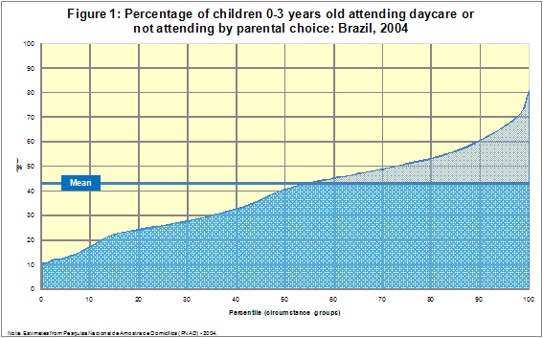

Figure 1 shows that in 2004 the mean coverage rate for daycare was slightly higher than 40%. Among the group of circumstances with the highest probability of having the option to attend daycare coverage was 80% and thus significantly below full coverage. Figure 2 presents results for the same opportunity measure in 2006.
As shown in Figure 2, mean coverage had increased to roughly 50% in 2006 and there was also an increase in coverage at the top of the distribution. Both figures also show that a significant fraction of the available opportunities are improperly allocated.
Figures 3 and 4 shows the analogous results for children aged 4-6 years old attending preschool or not attending by parental choice in 2004 and 2006, respectively.

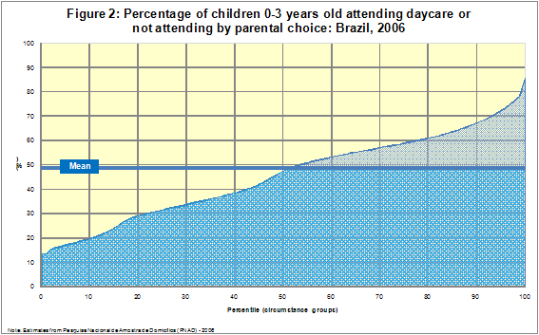
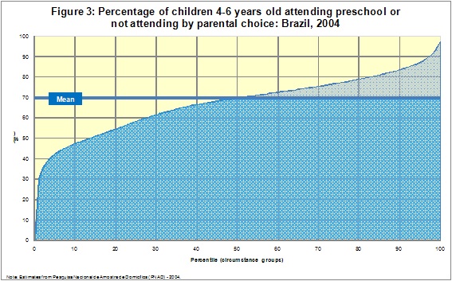
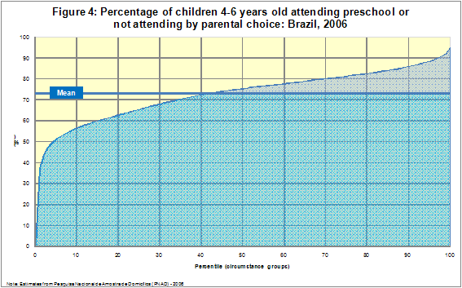

Figures 3 and 4 show that the mean coverage rate of preschool, around 70%, is considerably higher than the one for daycare. Moreover, among the group of circumstances with the highest probability of preschool attendance coverage is above 90% and thus close to full coverage. The comparison of Figures 1-2 and 3-4 shows that the fraction of the available opportunities that are improperly allocated are considerably smaller for preschool than for daycare.
Table 4 presents results for the average probability, dissimilarity index and the opportunity index for children aged 0-3 years old attending daycare or not attending by parental choice in 2004 and 2006. The results are presented for each age and for the 0-3 age bracket taken as a whole.
Table 4: Opportunity Index for children 0-3 years old attending day care or not attending by parental choice: Brazil, 2004 and 2006 – (%)
Two patterns emerge from Table 4. First, in each year, the average probability and the opportunity index increase with age, whereas the dissimilarity index decreases with age. For instance, in 2006, the opportunity index increases from 35% for children aged 0 years old to 51% for children aged 3 years old. This change reflects the increase in average probability from 43% to 58% and a reduction in the dissimilarity index from 19% to 12% between the two age categories.
Second, for each age, there is an increase in the average probability and the opportunity index between 2004 and 2006. There is also a decline in the dissimilarity index for all ages except 1-year old children. Between 2004 and 2006, the opportunity index for the 0-3 years old category increases from 36% to 41%, reflecting the increase in average probability from 43% to 49% and a reduction in the dissimilarity index from 17% to 16% between the two years.
Table 5 presents results for the average probability, dissimilarity index and the opportunity index for children aged 4-6 years old attending preschool or not attending by parental choice in 2004 and 2006. The results are presented for each age and for the 4-6 age bracket taken as a whole.
Table 5: Opportunity Index for children 4-6 years old attending preschool or not attending by parental choice: Brazil, 2004 and 2006 – (%)

Table 5 shows that the opportunity index is considerably higher for preschool than for daycare. Whereas opportunity for children aged 0-3 years old was 41% in 2006, the corresponding index for children aged 4-6 years old was 68% in the same year. This difference is due both to a higher average probability (73% for preschool and 49% for daycare) and a lower dissimilarity index (7% for preschool and 16% for daycare).
Table 5 also shows that, in each year, the average probability and the opportunity index are higher for 5 years old children than for 4 years old, whereas the dissimilarity index decreases. In contrast, the measure of opportunity is lower for 6 years old children than for 5 years old. This is probably due to the fact that some parents may decide to enroll their 6 years-old children in primary school instead of preschool.
As observed in the case of daycare, for each age there was an increase in the opportunity index between 2004 and 2006. Between 2004 and 2006, the opportunity index for the 4-6 years old category increased from 64% to 68%, reflecting the increase in average probability from 70% to 73% and a reduction in the dissimilarity index from 8% to 7% between the two years.
In summary, the results show that opportunity is increasing in Brazil for both daycare and preschool services. However, opportunity is considerably higher for preschool than for daycare, even after taking into account the fact that non-attendance may be a voluntary decision and not necessarily an indicator of lack of opportunity.
4.2. Human Opportunity Index
As discussed above, we believe that our opportunity index is more appropriate for the measurement of opportunity in the context of daycare and preschool than the human opportunity index. Since it is not clear if D&P services are a basic opportunity, it is possible that the fact that parents do not enroll their children in daycare or preschool does not reflect a lack of opportunity, but a parental choice given the preferences and constraints faced by the family. In any case, the comparison of the two opportunity measures is informative about the extent in which non-attendance in daycare or preschool is voluntary.
Figures 5 and 6 display a visual summary of the human opportunity index for children aged 0-3 years old attending daycare in 2004 and 2006, respectively. The Figures show that the mean coverage rate for daycare is considerably smaller (around 15%) when we consider the human opportunity index instead of our opportunity measure (higher than 40%). Among the group of circumstances with the highest probability of daycare attendance coverage was lower than 70% in 2006 for the human opportunity index, whereas it was higher than 80% for our opportunity measure. Moreover, the fraction of the available opportunities that are improperly allocated is considerably higher for the human opportunity measure.
These results suggest that, in the context of daycare services, the human opportunity index overestimates the degree of inequality of opportunity in society, because it associates non-attendance to lack of opportunity, whereas it may also result from a voluntary parental decision.
Figures 7 and 8 shows the results for the human opportunity index for children aged 4-6 years old attending preschool in 2004 and 2006, respectively. The Figures show that when we use the human opportunity attendance-based measure, the mean coverage rate of preschool, around 65%, is close to our option-based measure, which is around 70%. This indicates that a small fraction of parents choose not to enroll their children in preschool and suggests that preschool attendance may be considerably closer to a basic opportunity than daycare.
Table 6 presents results for the human opportunity index and the associated average probability and dissimilarity index for children aged 0-3 years old attending daycare in 2004 and 2006. As we obtained for our opportunity index, two patterns emerge from Table 6. First, in each year, the average probability and the opportunity index increase with age, whereas the dissimilarity index decreases with age. Second, for each age except age 0, there is an increase in the average probability and the opportunity index between 2004 and 2006.

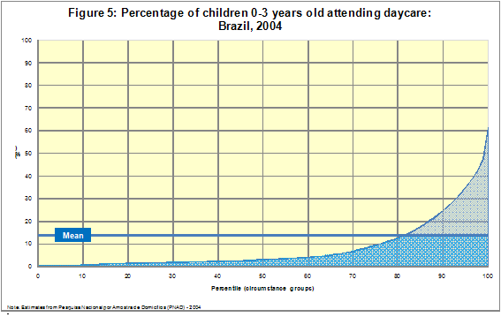
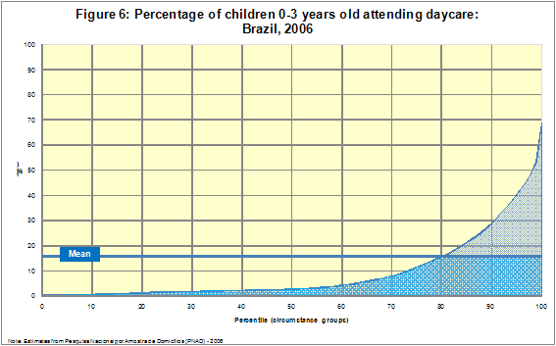
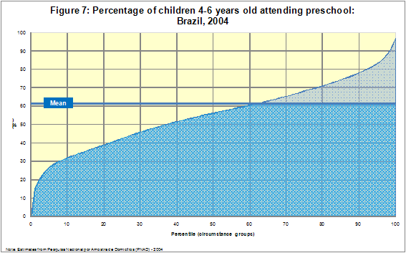

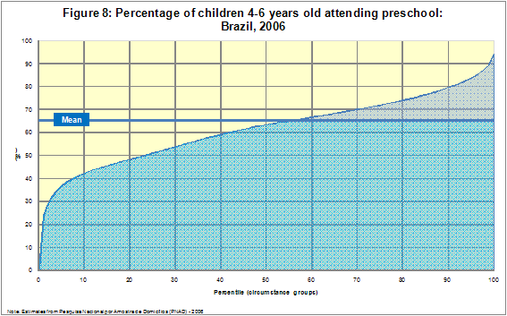

However, as suggested by the Figures above, the human opportunity index is much smaller than our opportunity index in both years. Specifically, the latter was 41% in 2006, whereas the human opportunity index was only 9% in the same year. As discussed above, this suggests that the human opportunity index overestimates the degree of inequality of opportunity in society, because it associates non-attendance to lack of opportunity, whereas it may also result from a choice by the parents.
Table 6: Human Opportunity Index for children 0-3 years old attending day care: Brazil, 2004 and 2006 – (%)

Table 7 presents results for the human opportunity index and the associated average probability and dissimilarity index for children aged 4-6 years old attending preschool in 2004 and 2006. The Table shows that the human opportunity index is considerably higher for preschool than for daycare. While opportunity for children aged 0-3 years old was 9% in 2006, the corresponding index for children aged 4-6 years old was 60% in the same year.
Table 7: Human Opportunity Index for children 4-6 years old attending preschool: Brazil, 2004 and 2006 – (%)
Table 7 also shows that the human opportunity and our opportunity index are similar for preschool. For instance, in 2006 the former was 60%, which is close to the option-based opportunity measure of 68% in the same year. Moreover, the difference between the two indexes decreases with age. For instance, for children aged 4 years old, the difference was 15 percentage points (66% and 51% for the option-based and human opportunity index, respectively), whereas for children aged 5 years old the difference declines to 9 p.p. (78% and 69%).
Taken together, the results show large differences between our opportunity index and the human opportunity index for children aged 0-3 years old and considerably smaller differences for children aged 4-6 years old. This indicates that for children aged 0-3 years old there is a significant fraction of parents that prefer not to enroll their children in daycare. On the other hand, as children’s age increases, the proportion of children that do not attend school declines significantly, which suggests that preschool may be closer to a basic opportunity than daycare.
4.3. Opportunity Index by Region and Race
Table 8 presents results for the average probability, dissimilarity index and our opportunity index by geographical region for children aged 0-3 years old attending daycare or not attending by parental choice in 2004 and 2006.
Table 8: Opportunity Index for children 0-3 years old attending daycare or not attending by parental choice by Region: Brazil, 2004 and 2006 [in %]

Table 8 shows that opportunity is higher in the richer regions, Southeast and South, where it is close to 58% in 2006, than in poorer regions, Northeast, North and Midwest, where it varies between 23% and 38%. These differences arise mainly from higher average probabilities in the Southeast and South, even though they also have smaller dissimilarity indexes. It can also be observed that, with exception of the North, all regions had an increase in opportunity between 2004 and 2006.
Table 9 presents results for the average probability, dissimilarity index and our opportunity index by region for children aged 4-6 years old attending preschool or not attending by parental choice in 2004 and 2006. Table 9 shows that the regional differences in opportunity are considerably smaller for preschool than for daycare. The Southeast had an opportunity index of 75% in 2006, while in the other regions it varied between 56% and 68%. It can also be observed that, with exception of the Midwest, all regions had an increase in opportunity between 2004 and 2006.
Table 10 presents results for the average probability, dissimilarity index and our opportunity index by race for children aged 0-3 years old attending daycare or not attending by parental choice in 2004 and 2006. Table 10 shows that for all ages and both years opportunity is higher among whites than among non-whites. In particular, in 2006 opportunity was 48% for whites and 36% for non-whites. This difference is mainly due to a higher average probability (55% for whites and 43% for non-whites), even though the dissimilarity index is smaller for whites. For both whites and non-whites, opportunity increased between 2004 and 2006.
Table 9: Opportunity Index for children 4-6 years old attending preschool or not attending by parental choice by Region: Brazil, 2004 and 2006 – (%)

Table 11 shows the results for the average probability, dissimilarity index and our opportunity index by race for children aged 4-6 years old attending preschool or not attending by parental choice in 2004 and 2006.
Table 10: Opportunity Index for children 0-3 years old attending daycare or not attending by parental choice by Race: Brazil, 2004 and 2006 – (%)
Table 11: Opportunity Index for children 4-6 years old attending preschool or not attending by parental choice by Race: Brazil, 2004 and 2006 – (%)

Table 11 shows that the differences in opportunity between whites and non-whites are considerably smaller for preschool than for daycare. In particular, white children had an opportunity index of 71% in 2006, while for non-white children the corresponding value was 66%. It can also be observed that for both white and non-white children there was an increase in opportunity between 2004 and 2006.
The results stratified by region and by race are consistent with the findings for the whole sample. Specifically, opportunity is increasing in Brazil for both daycare and preschool services for white and non-white children and almost all regions. However, opportunity is considerably higher for preschool than for daycare, and differences between races and regions are significantly smaller for preschool than for daycare.
4.4. Opportunity Profile
In this section we present the results for the profile of the most-disadvantaged and least-disadvantaged groups in terms of probability of having the opportunity to attend daycare or preschool. The profile is based on the circumstances that are used in the construction of our measures of opportunity.
Specifically, we perform the exercise in the following three steps. First, we rank in increasing order the predicted probabilities of having the opportunity to attend a preprimary school (i.e. the${\hat{p}}_{i}$’s). Second, we identify the most-disadvantaged (least- disadvantaged) group by summing the children from the bottom (top) of the distribution up to the point where they represent 10 percent of the overall population of children of the corresponding age. Third, we compute the distribution of children for each circumstance variable in the most- and least-disadvantaged groups of opportunity. We believe this exercise can be useful for policy purposes to the extent that it informs policymakers the profile of children that have the lowest opportunity to attend a preprimary school establishment.
Table 12 contains the profile by age for children between 0 and 3 years old in 2004 and 2006. The table reveals the existence of considerable differences between the two disadvantaged groups in both years. While non-white children constitute the majority in the most-disadvantaged group, no less than 78% of the least-disadvantaged group is composed of white children. Regional differences are also marked, with the vast majority of disadvantaged children living in the Northeast region, whereas the South and Southeast are the area of residence of at least 80% of the least-disadvantaged children.
Another pronounced difference occurs in terms of the educational level of the head of the household. More than 95% of children in the most-disadvantaged group live in dwellings where the head did not complete primary education. In contrast, at least 75% (60%) of children in the least-disadvantaged group reside in households whose head has at least primary (secondary) education. Not surprisingly, the vast majority of opportunity-deprived children are below the median per capita income (around 90%), whereas the opposite happens for children in the least-disadvantaged group (around 80%).
Table 12: Most-disadvantaged and least-disadvantaged circumstance groups for children 0-3 years old attending daycare or not attending by parental choice: Brazil, 2004 and 2006 – (%)

A smaller difference appears in terms of type of municipality, where more than 90% of disadvantaged children of all ages live in non-metropolitan areas and the proportion of least-disadvantaged children in those areas starts high at age 0 but decreases towards age 3. Having at least two siblings is more pronounced for the bottom than for the top group of children. The proportion of children that live with only one parent in the most-disadvantaged group tend to be a little higher than that of children in the top group. There is no clear pattern in terms of the gender of the child. Though there is some variation across ages, the proportion of boys attending daycare is around 50 percent for both disadvantaged groups in both years.
Table 13 presents the profile by age for children between 4 and 6 years old in 2004 and 2006. As for the younger group, there is a clear difference in terms of race between the two circumstance groups: non-white children are prevalent in the most-disadvantaged group, the opposite happening for the least-disadvantaged group. Results are also similar between older and younger children in terms of the schooling level of the head: the vast majority of children in the most-disadvantaged (least-disadvantaged) group live in households where the head did not complete (complete) primary education.
Table 13 also shows that more than 80% of children in the most opportunity-deprived group live in families whose per capita income is below the median, whereas at least 85% of least-disadvantaged children are above it. This is also similar to what has been observed for younger children. The regional distribution is more mixed for older children, with much less concentration of least-disadvantaged children in the South and Southeast (except for 6 year olds) and much more spreading of most-disadvantaged children across regions.
The vast majority of older children in the most-disadvantaged group live in non-metropolitan areas and the distribution of least-disadvantaged children seems to be more balanced and stable across ages between metropolitan and non-metropolitan areas. The proportion of older children in the bottom group of opportunity that has at least two siblings (around 70%) is higher than for the younger group (around 50%); the same does not happen for the least-disadvantaged group, for whom this proportion keeps around 10%. There is a lower proportion of older children in the most-disadvantaged group living in a single-parent household as compared to younger children in the corresponding disadvantaged group. The opposite seems to happen for the least-disadvantaged group. Boys and girls attending preschool also tend to be reasonably balanced in both disadvantaged groups.
5. Conclusion
In this paper we measured the degree of inequality of opportunity of access of children to daycare and preschool services in Brazil using an opportunity index that modifies the human opportunity index proposed by Barros et al. (2008a) and Barros et al. (2008b) and used in Barros et al. (2009) to measure inequality in the access to basic opportunities in Latin America and the Caribbean.
In the construction of the human opportunity index proposed by these authors, access to a service and, in particular, to daycare and preschool, is equivalent to actual attendance. However, we argue that the relevant measure of opportunity of access to daycare and preschool services in Brazil is that children should have the option to attend daycare or preschool and not attendance per se. This measure is consistent with several changes in the legislation related to preprimary education that have been enacted in Brazil since the late eighties.
We constructed an opportunity measure that included not only attendance but also the voluntary option not to enroll children in daycare or preschool. For this purpose, we used a supplementary questionnaire that was included in the 2004 and 2006 versions of PNAD, the main Brazilian household survey. This supplement asked the main reason why children were not attending daycare or preschool, one of the reasons being that the parents did not want their children to attend daycare or preschool.
The analysis in this paper is subject to one important caveat. It is possible that parents that answer that they do not want their children to attend daycare or preschool are in fact restricted by lack of income and vacancies in daycare and preschool establishments. We provided some evidence that the relationship between the response “parents do not want children to attend” and income and the age of the child is significantly different from the relation between these variables and the motives identified as capturing lack of resources or vacancies. However, this limitation of the analysis should be considered in the interpretation of the results.
The results show that opportunity increased in Brazil for both daycare and preschool services between 2004 and 2006. However, opportunity is considerably higher for preschool than for daycare, even after taking into account the fact that non-attendance may be a voluntary decision and not necessarily an indicator of lack of opportunity.
There are large differences between our opportunity index and the human opportunity index for children aged 0-3 years old and considerably smaller differences for children aged 4-6 years old. This indicates that for children aged 0-3 years old there is a significant fraction of parents that prefer not to enroll their children in daycare. On the other hand, as children’s age increases, the proportion of children that do not attend school declines significantly, which suggests that preschool may be closer to a basic opportunity than daycare.
The results for region and race show that opportunity increased in Brazil for both daycare and preschool services for white and non-white children and almost all regions. However, opportunity is considerably higher for preschool than for daycare, and differences between races and regions are significantly smaller for preschool than for daycare.
The profile comparison of the 10% most-disadvantaged and least-disadvantaged children showed large differences for many circumstance variables for both children aged 0-3 and 4-6 years old. In particular, a typical child in the most-disadvantaged group is non-white, lives in a household below the median per capita income and whose head did not complete the primary degree. The opposite applies to children in the top of the distribution of opportunity to attend a daycare or preschool establishment in Brazil.
Table 13: Most-disadvantaged and least-disadvantaged circumstance groups for children 4-6 years old attending preschool or not attending by parental choice: Brazil, 2004 and 2006 – (%)
References
Barros, R. P., Vega, J. M. and Saavedra, J. (2008a). “Measuring Inequality of Opportunities for Children”. Discussion Paper. World Bank.
Barros, R. P, Vega, J. M. and Saavedra, J. (2008b). “Measuring the Progress Toward Basic Opportunities for All”. Mimeo.
Barros, R. P, Ferreira, F., Vega, J. M. and Saavedra, J. (2009). Measuring Inequality of Opportunities in Latin America and the Caribbean. The World Bank. Washington, DC.
Becker, G. (1993). Human Capital: A Theoretical and Empirical Analysis with Special Reference to Education. 3rd ed. The University of Chicago Press.
Carneiro, P. and Heckman, J. (2003). “Human Capital Policy” In Heckman, J. Krueger, A. and Friedman, B. Inequality in America: What Role for Human Capital Policies?, MIT Press.
Cunha, F, Heckman, J., Lochner, L. and Masterov, D. (2006). “Interpreting the Evidence on Life Cycle Skill Formation”. In: Hanushek, E. and Welch, F. (eds). The Handbook of Economics of Education, chapter 12, pp. 697-812.
Cunha, F. and Heckman, J. (2009). “The Economics and Psychology of Inequality and Human Development”. NBER Working Paper no. 14695.

* We are grateful to Jere Behrman, Cesar Bouillon and Florencia Lopez-Boo for comments on the first draft of this paper.
◻ Pesquisador do IPEA.
▪ Professor do IBMEC-RJ.
Note that T can also be interpreted as the total number of opportunities that the “vulnerable” circumstance groups (i.e. those with p(x) ≤ μ) need for their specific coverage rates to attain the overall average, expressed as a proportion of the total number of opportunities required for full coverage.
In the next section we describe the main features of PNAD.
For expositional simplicity, we describe the empirical methodology in terms of opportunity to attend daycare services, but the same framework applies to the case of preschool.
The rural area of the North region of the country only entered the sample after 2004. This area is included in the sample we use to obtain our main results.
Since 2006 the age of entry to primary school changed from 7 to 6. There is a transition period until 2010, when the change needs to have been fully implemented.
Two additional reasons for non-attendance were included in the PNAD 2006’s supplementary questionnaire (“dismissed from school or daycare” and “school or daycare does not offer higher degrees”).
All other reasons together do not sum up to 5 percent in each year for all ages. The questionnaire in both years included four other reasons, “help in domestic chores”, “work or looking for work”, “parents prefer that the child work”, and “concluded aimed degree”, that are not applicable to children under 6, though they appear residually due to misresponse.
It is noticeable, however, the absence of a motive related to the (perceived) quality of D&P services.
We are grateful to Jere Behrman for raising this issue.
The negative relationship between “do not want children to attend” and family income is stronger for children between 4 and 6 years old.
It can be argued that some of these variables, such as per capita family income, are endogenous from the standpoint of the family. In this paper, we follow the opportunity literature and include them in the set of circumstances because they are beyond the children’s control.
To capture location, Barros et al. (2009) used only a dummy variable indicating whether children lived in an urban or rural area.
The group of whites includes children from Asian origins. The non-white group is composed by blacks, mulattos, and indigenous people.

