Real Exchange Rate, Income Distribution and Structural Change in a Modified Kaldorian Model of Demand-Led Growth

Rogério Sobreira
Associate Professor of Finance and Economics, Brazilian School of Public and Business Administration, Getulio Vargas Foundation (EBAPE/FGV). E-mail: rogerio.sobreira@fgv.br

José Luís Oreiro
Associate Professor at Department of Economics of Universidade de Brasília (UnB), and Researcher at National Scientific Council (CNPq). E-mail: jlcoreiro@terra.com.br. Web-page: www.joseluisoreiro.ecn.br

Abstract: The objective of this paper is to present a modified Kaldorian model of demand-led growth that incorporates monetary policy rules, capital mobility and floating exchange rates in the traditional core of demand led (Kaldorian) growth models. The model presented here will be used for two purposes. First of all, we will analyze the effects of an ITR over long-run growth. An important result of the analysis made here is that the existence of a balanced growth path for real output (i.e. a growth rate of output equal to warranted growth rate in Harrodian terms) require flexible long-run target inflation; that is, a long run value for target inflation that is adjustable to the international rate of inflation. Second, we will analyze the long-run effect of real exchange rate appreciation over the growth rate of real output. It will be argued that a permanent change of real exchange rate will cause a structural change in the economy at hand by means of a change in the level of productive specialization which will cause changes in the level of marginal propensity to import and in the level of exports multiplier. An important result of the analysis made here is that policies designed to reduce the wage share will produce a real exchange rate appreciation, causing a reduction in the growth rate of real output. This means that growth is wage–led in a Kaldorian model where real exchange rate matters for the determination of the level of productive specialization.

Key-Words: Dynamic Models, Export-led Growth, Structural Change.

Resumo: o objetivo deste trabalho é apresentar um modelo kaldoriano modificado de crescimento puxado pela demanda que incorpora as regras de política monetária, mobilidade de capitais e regime de câmbio flutuante no esquema tradicional dos modelos de crescimento liderados pela demanda (kaldorianos). O modelo apresentado aqui será utilizado para dois propósitos. Em primeiro lugar, vamos analisar os efeitos de uma regra de metas de inflação sobre o crescimento de longo prazo. Um resultado importante da análise feita aqui é que a existência de padrão de crescimento equilibrado para o produto real (i.e., uma taxa de crescimento do produto igual à taxa de crescimento garantida do produto em termos harrodianos) exige metas de inflação de longo prazo flexíveis, isto é, um valor de longo prazo para a meta de inflação que seja ajustável à taxa internacional de inflação. Em segundo lugar, vamos analisar os efeitos de longo prazo de uma apreciação da taxa real de câmbio sobre a taxa de crescimento do produto real. Argumentamos que uma mudança permanente na taxa de câmbio real irá causar uma mudança estrutural na economia por conta de uma mudança no nível de especialização do produto que levará a mudanças no nível de propensão marginal a importar e no nível do multiplicador das exportações. Um importante resultado da análise desenvolvida aqui é que políticas desenhadas para reduzir a participação nos salários vão produzir uma apreciação na taxa real de câmbio, provocando uma redução na taxa de crescimento do produto real. Isto significa que o crescimento é liderado pelos salários em um modelo kaldoriano, onde a taxa de câmbio real é importante para a determinação do nível de especialização do produto.

Palavras-chave: modelos dinâmicos, crescimento liderado pelas exportações, mudança estrutural

JEL Codes: O40, O47
Área Anpec: Área 6 – Economia Internacional
Real Exchange Rate, Income Distribution and Structural Change in a Modified Kaldorian Model of Demand-Led Growth

1 – Introduction.
Neoclassical growth models take for granted that the ultimate limit to long-run growth is the supply of factors of production (Solow, 1957). Aggregate demand is relevant only to determine the degree of productive capacity in the short-run, but has no lasting impact over the growth rate of productive capacity. In the long-run, Say’s Law is valid, that is, supply determines demand.
However, supply of factors of production is not really independent of demand. The relation between the supply of production factors and aggregate demand was analyzed by Kaldor (1988), giving a new stimulus to the so-called demand-led growth theory. The starting point of the demand-led growth models is that means of production used in a capitalist economy are themselves goods produced within the system. If that is so, the “supply” of means of production should never be considered as a datum independent of the demand for then. In this framework, the fundamental economic problem is not the allocation of a given quantity of resources over the possible alternatives; but the determination of the rate of growth of these resources. In the words of Setterfield:
“The use of produced means of production implies that the ´scarcity of resources´ in processing activities cannot be thought of as being independent of the level of activity in the economy. What is chiefly important in processing activities is the dynamic propensity of the economy to create resources (that is, to deepen and/or widen its stock of capital) rather than the static problem of resource allocation” (1997, p.50).
Kaldor´s ideas about demand-led growth have been presented in formal models of cumulative causation where the rate of growth of output is determined by the growth rate of exports, which is determined by the growth rate of labor productivity (considering a fixed exchange-rate regime) induced by the growth rate of real output. In this setting, it is possible the construction of dynamic models where initial conditions largely determine the long-run growth rate.
Kaldorian cumulative causation models have, in general, four equations: a first equation where the growth rate of real output is a function of the growth rate of exports; a second equation in which the growth rate of exports is a function of the rate of change of terms of trade and of the growth rate of World’s income; a third equation that specifies the productivity growth rate as a function of the growth rate of real output (a simple formalization of Kaldor-Verdoorn law); and a fourth equation where the rate of change of domestic prices is determined by the rate of change in nominal wages, the growth rate of productivity and the rate of change of nominal exchange-rate. It is also assumed the existence of a fixed-exchange rate regime and/or that price-elasticity of exports are zero.
Up to now, no effort has been done in order to incorporate to these dynamic models some important aspects of open-economy macroeconomics as, for example, the openness of capital account and the existence of a floating exchange-rate regime. Besides that, Kaldorian models of cumulative causation ignore completely the effects of monetary policy over long-run growth, what is a surprising feature, given the obvious Keynesian origin of this class of growth models.
Another missing element in Kaldorian cumulative causation models is the level of real exchange rate. Kaldorian models take from granted that the level of real exchange rate is irrelevant for long-run growth since (i) exports growth depends on the rate of change of real exchange rate, not on the level of this variable; and (ii) empirical studies shows that price elasticity of exports is low. In the words of McCombie and Roberts:
“There are numerous studies estimating import and export demand functions as part of a test of Thirwall’s law, and these generally report estimated price elasticities that are either statistically insignificant, low or have a priori unexpected signs”(2002, p.92).
These studies, however, do not take in consideration the impact of changes in the real exchange-rate over the value of exports multiplier. This variable must be considered a structural parameter that depends on the level of productive specialization of the economy; i.e. the number of different goods that an economy produces in a point of time. As shown by Dosi, Pavitt e Soete (1990, ch.7) an increase in the level of productive specialization of an economy will increase the marginal propensity to import, decreasing the value of exports multiplier. This reduction of exports multiplier will cause a reduction in the rate of output growth for a given growth rate of exports. Since real exchange rate is one of the determinants of the degree of productive specialization, then a real exchange rate appreciation will cause a reduction in the growth rate of output.
The objective of this article is to present a modified Kaldorian model of demand-led growth that incorporates monetary policy rules, capital mobility and floating exchange rates in the traditional core of demand led (Kaldorian) growth models. The model presented here will be used for two purposes. First of all, we will analyze the effects of an ITR over long-run growth. An important result of the analysis made here is that the existence of a balanced growth path for real output (i.e. a growth rate of output equal to warranted growth rate in Harrodian terms) require a flexible long-run target inflation, that is, a long run value for target inflation that is adjustable to the international rate of inflation. Second, we will analyze the long-run effect of real exchange rate appreciation over the growth rate of real output. An important result of the analysis made here is that policies designed to reduce the wage share will produce a real exchange rate appreciation, causing a reduction in the growth rate of real output. This means that growth is wage–led in a Kaldorian model where real exchange rate matters for the determination of the level of productive specialization.
The present article is organized in 6 sections, including the introduction. In section 2 we show the theoretical structure of the modified Kaldorian cumulative causation model, supposing the degree of productive specialization as being given and independent of real exchange-rate. In section 3 we show the steady-state solution of the model at hand. Section 4 is dedicated to the numerical simulation of the model presented in section 2. Section 5 will incorporate the real exchange rate as one of the determinants of the exports multiplier in order to analyze the effects of changes in income distribution over long-run growth. Section 6 presents the final remarks and conclusions obtained in the present paper.
2 - The Theoretical Model.
2.1 A modified Kaldorian demand-led growth model.

The model presented here is an extension of the Kaldorian demand-led growth developed by Setterfield (1997). It is well known that the standard Kaldorian demand-led growth model has four dynamic equations: a first equation relating the growth rate of labor productivity with the growth rate of real output (the so-called Kaldor-Verdoorn Law), a second equation presenting the rate of inflation as the difference between the rate of increase in nominal wages and the growth rate of labor productivity, a third equation showing the growth rate of exports as a function of the evolution of price-competitiveness of exports and the growth rate of world’s income and a forth and last equation showing the growth rate of real output as a function of the growth rate of exports.
In the model that we will develop now, we will do some modifications in the basic structure of the standard Kaldorian demand-led growth model. First of all, as suggested by Palley (2002), we will add two new equations to the standard model with the purpose to analyze the dynamics of the productive capacity of the economy. In fact, standard models of demand-led growth say nothing about the “supply side” of the economy, that is, about the evolution of productive capacity through time. This omission will be solved by means of adding a dynamic equation relating the growth rate of productive capacity with the investment rate, in a similar fashion of what was done by Domar (1946). The second equation to be introduced is a investment function in which investment rate at time t will be supposed as being a function of the level of capacity utilization in time t-1 – according with the so-called accelerator model of investment behavior – and of the real interest rate of time t-1.
In second place, we will suppose that the rate of change of nominal wages is not uniform in all over the world economy (Setterfield, 1997, p.55), but is country-specific. In this setting, we will suppose the existence of the so-called real wage resistance; that is insensitivity of real wage rates to changes in the rate of domestic price inflation and/or in the rate of international price inflation. Labor Unions can manage to set the rate of change of nominal wages at a level that is not only sufficient to keep real wages constant through time, but also high enough to incorporate productivity gains.
In third place, we will suppose an economy that operates under a floating exchange-rate regime in a setting of restricted (imperfect) capital mobility due to the presence of some form of capital controls. In this framework, the rate of change of nominal exchange-rate is supposed to be a linear function of the difference between the domestic nominal interest rate and the international nominal interest rate adjusted by the country-risk premium. Because of that, the interest rate differential will have an impact over the domestic rate of inflation (by means of exchange-rate variations) and overt the price-competitiveness of exports, opening a channel by which monetary policy can have an influence over long-run growth rate.
Finally, we will suppose that monetary policy is conducted under the institutional framework of an Inflation Targeting Regime, and the Central Banks sets nominal interest rates at each period based in a version of the so-called “Taylor rule”.
2.2 The structure of the economy.
The economy under consideration is an open economy that produces an homogenous output that can be used for both consumption and investment. Output is produced by means of a fixed coefficient technology (Leontieff) that uses only domestic labor and capital as inputs to production. Domestic goods are considered to be imperfect substitutes for foreign goods, so that purchasing power parity does not hold. Real exchange rate is defined simply as the ratio between the price of domestic goods relative to price of foreign goods denominated in domestic currency. Domestic prices are set by firms according to a simple mark-up rule over unitary variable costs. Labor unions set the rate of change of nominal wages in order not to only to preserve real wages in face of increases in domestic and foreign good prices, so there is real wage resistance, but also to incorporate productivity gains. There is imperfect mobility of capital and a floating exchange rate regime, so the rate of change of nominal exchange rate depends on the difference between domestic and international nominal interest rates adjusted by the risk premium. There is also an ITR so that nominal interest rates are set by monetary authorities in order do achieve a target inflation in the long run.
The structure of the following model can be presented by means of the following system of equations:
$$\begin{aligned}(1) {\hat{q}}_{t}=r+α{\hat{Y}}_{t−1} \\ (2) {\bar{\hat{Y}}}_{t}=σ\frac{I_{t−1}}{Y_{t−1}} \\ (3) \frac{I_{t}}{Y_{t}}=ϕ_{0}+ϕ_{1} \left(u_{t−1}\right)+ϕ_{2}\left(i_{t−1}−{\hat{p}}_{t−1}\right) \\ (4) {\hat{u}}_{t}={\hat{Y}}_{t}−{\bar{\hat{Y}}}_{t} \\ (5) {\hat{p}}_{t}={\hat{w}}_{t}−{\hat{q}}_{t} \\ (6) {\hat{w}}_{t}=δ {\hat{p}}_{t−1}+ε\left({\hat{e}}_{t}+{\hat{p}}_{w,t}\right)+{\hat{q}}_{t−1} \\ (7) {\hat{X}}_{t}=β\left({\hat{p}}_{w,t}+{\hat{e}}_{t}−{\hat{p}}_{t}\right)+γ {\hat{Y}}_{w,t} \\ (8) {\hat{Y}}_{t}=λ{\hat{X}}_{t} \\ (9) {\hat{e}}_{t}=ϑ\left(i_{t}−i_{w,t}−ρ\right) \\ (\text{10}) i_{t}^{d}=\left(i_{w,t}+ρ\right)+θ_{1}\left({\hat{p}}_{t−1}−π_{t}^{}\right)+θ_{2}({\hat{Y}}_{t−1}−{\bar{\hat{Y}}}_{t−1}) \\ (\text{11}) i_{t}=θ_{0}i_{t}^{d}+(1−θ_{0})i_{t−1} \\ (\text{12}) π_{t}^{}={\text{ψπ}}_{t−1}^{}+\left(1−ψ\right)π_{\text{LP}} \end{aligned}$$
Where: is the growth rate of labor productivity in period t , ${\hat{Y}}_{t}$is the growth rate of real output, ${\bar{\hat{Y}}}_{t}$ is the growth rate of productivity capacity in period t, $I_{t}$is planed investment in period t, ${\hat{u}}_{t}$ is the rate of change of capacity utilization, ${\hat{p}}_{t}$is the rate of inflation in period t, ${\hat{w}}_{t}$is the rate of change in nominal wages in period t, ${\hat{e}}_{t}$is the rate of change in nominal exchange rate in period t, ${\hat{p}}_{w,t}$is the rate of inflation in the rest of the world in period t, ${\hat{Y}}_{w,t}$is the rate of growth of world’s income in period t, ${\hat{X}}_{t}$ is the growth rate of exports in period t, $i_{w,t}$ is the international short-term interest rate, $ρ$is the country’s risk premium; $i_{t}$ is the nominal interest rate set by the Central Bank in period t, $i_{t}^{d}$ is the nominal interest rate target for period t, $π_{t}^{}$is the target inflation for period t and $π_{\text{LP}}$ is the long-run target for inflation rate. The constants $r,α,σ,δ,ε,β,γ,λ,θ_{0},θ_{1},θ_{2},ϕ_{1},ψ \text{and} γ$are all positive, but $ϕ_{2},ϑ$ are negative.
The equation (1) of the system presented above represents the “Kaldor-Verdoorn Law”, according to which the growth rate of labor productivity is a positive function of the growth rate of real output due to the existence of static and dynamic economies of scale.
Equation (2) presents the growth rate of productive capacity in period t as a function of the rate of investment of period t-1. In this setting, the coefficient$σ$must be understood – as in Domar (1946) – as the “social productivity of investment”, that is, as a coefficient that determines the increase in productivity capacity or in “potential output” that results from an increase in the level of realized investment expenditures.
Equation (3) shows the rate of investment that is desired by entrepreneurs for period t as a function of the rate of capacity utilization in period t-1 and real interest rate in period t-1. This specification of the investment function combines the so-called “principle of acceleration” (Harrod, 1939) with the Keynesian theory of the “marginal efficiency of capital” (Keynes, 1936, ch.11) according to which desired investment is a negative function of the rate of interest. In equation (3) we are supposing that the relevant nominal interest rate for investment decisions is the short-term nominal interest rate fixed by monetary authorities. This hypothesis needs further explanation. Normally, investment is considered to be dependent of long term interest rate, since it is the appropriate measure of the opportunity cost of capital for long term investment decisions. However, according to the liquidity preference theory of interest rate determination, long term assets must pay a liquidity premium over short term assets in order to compensate wealth owners for the lower liquidity of the former compared to the latter (Carvalho, 1992, ch.5). This means that for a constant liquidity preference of wealth owners, liquidity premium will be constant, making long term interest rate a linear function of the short term rate. In this setting, investment decisions can be, for sake of simplicity, considered to be a simple function of short term interest rate.
Equation (4) shows the rate of change of capacity utilization as being equal to the difference between the growth rate of real output and the growth rate of productive capacity.
Equation (5) shows the rate of inflation in period t as being equal to the rate of change in nominal wages minus the rate of growth of labor productivity. This equation is deduced from a mark-up pricing rule such as$p=(1+z)\left[\frac{w}{q}\right]$, where: z is the mark-up rate, w is the nominal wage rate and q is the average productivity of labor (Taylor, 1989).
Equation (6) shows the rate of change of nominal wages as a function of the rate of domestic price inflation in period t-1, the rate of international price inflation measured in domestic currency in period t-1 and the rate of growth of labor productivity. This equation is deduced from the definition of the real wage rate from the point of view of workers in a setting where: i) workers spent a constant share of their wage income in consumption goods imported from the rest of the world; ii) labor unions manage to set a rate of change of nominal wages at the required level to hold the real wage rate constant through time; in other words, we are supposing the existence of real wage resistance; iii) labor unions are also capable to incorporate the rate of productivity growth in their wage demand.
Real wage rate from the point of view of workers for an open economy can be expressed by (Setterfield, 1997, ch.3):
(6a) $ω=\frac{w_{t}}{{\left(p_{t}^{e}\right)}^{δ}{\left(e_{t}p_{w,t}\right)}^{ε}}$
Where: $ω$is the real wage rate from the point of view of workers,$p_{t}^{e}$is the expected level of domestic prices for period t, $δ$is the share of wage income spent in domestic goods and $ε$ is the share of wage income spent in imported goods, $δ$+$ε$ = 1
For derivation of equation (6) from equation (6a), we suppose that Labor Unions follow a simple rule for expectations formation about the level of domestic prices:$p_{t}^{e}=p_{t−1}$. This means that Labor Unions have a form of adaptive expectations about domestic price level.
Equation (7) represents the growth rate of exports as a function of the rate of change of real exchange-rate (by definition, equals to rate of change of nominal exchange rate plus the international rate of inflation minus the domestic rate of inflation) and of the rate of growth of world’s real income. We must emphasize that $γ$ is the income-elasticity of exports.
Equation (8) shows the growth rate of real output as a function of the growth rate of exports. In this setting, coefficient $λ$ must be understood as the non-resident autonomous expenditure multiplier.
Equation (9) shows the rate of change in nominal exchange-rate as a linear function of the difference between domestic nominal interest rate and the international nominal interest rates adjusted by the country’s risk premium. So we are considering an economy where prevails a floating exchange rate regime in a context of restricted capital mobility due to the existence of some form of capital controls.
Equations (10) and (11) presented the monetary policy rule adopted by the Central Bank. In equation (10) we can see that the nominal interest rate set by the Central Bank in period t has three determinants. The first one is the long-run equilibrium value for nominal interest rate, given by the sum of international interest rate and the risk-premium. The second component is the difference between actual rate of inflation and the target rate of inflation for period t. The third and last determinant is the difference between the actual growth rate of real output and the growth rate of productive capacity. In this setting, we are supposing that the Central Bank will change the nominal interest rate relative to its equilibrium value in order to achieve two policy objectives: kept inflation in line with target inflation for that period and to minimize the gap between the actual growth rate of real output and the growth rate of productive capacity.
Equation (11) shows that the Central Bank adjusts slowly the actual value of nominal interest rate to the desired value of this rate, determined by equation (10). This equation is a simple formalization of the stylized fact about the behavior of the Central Banks in the operation of monetary policy, according to which Central Banks try to avoid sudden changes in nominal interest rates, in order to minimize interest-rate volatility (Barbosa, 2004, p.105).
Finally, equation (12) shows that inflation target for period t is a weighted average of the rate of target inflation for period t-1 and the long-run inflation target. In this setting we are supposing that Central Bank operates monetary policy in order to produce a gradual convergence of actual inflation to the long-run inflation target, defined in an exogenous way.
2.3 The reduced form of the model
Once that we have specified the structure of the model, it will be presented in a reduced form. After putting equations (1), (6) and (9) in (5) we arrive at the following expression:
$(\text{14}) {\hat{p}}_{t}=δ {\hat{p}}_{t−1}+ε\left(ϑ\left(i_{t}−i_{w,t}−ρ\right)+{\hat{p}}_{w,t}\right)−α\left({\hat{Y}}_{t−1}−{\hat{Y}}_{t−2}\right)$
In equation (14) we can see that the rate of inflation in period t is a function of the last period rate of inflation, so that there is a strong degree of inflation inertia in this economy. Besides that, we can see also that growth acceleration between t-1 and t-2 is associated with a reduction in the rate of inflation. This surprising result is due to the effects of growth acceleration over the rate of growth of productivity, which causes a reduction of the rate of inflation. Finally, we can see that monetary policy has effect over inflation by means of the exchange rate channel, since an increase in nominal interest rates will produce a reduction in the rate of change of nominal exchange rate, reducing the rate of wage inflation that is required to keep real wages constant through time.
Getting (1), (7), (9) and (14) in (8) we arrive at the following expression:
$${(\text{15}) {\hat{Y}}_{t}=\text{λβ}\left[α\left({\hat{Y}}_{t−1}−{\hat{Y}}_{t−2}\right)+\left(1−ε\right)\left({\hat{p}}_{w,t}+ϑ\left(i_{t}−i_{w,t}−ρ\right)\right)−δ{\hat{p}}_{t−1}\right]+\text{γλ \{}\hat{Y}}_{w,t}$$
Equation (15) shows that:
- A growth acceleration between t-1 and t-2 will have a positive impact over the growth rate of real output in period t.
- An increase in the growth rate of world’s income will increase the rate of growth of real output.
- A reduction in the previous period rate of inflation will increase the growth rate of real output.
Lagging (3) in one period and getting the resulting expression in (2), we arrive at the following expression:
$$(\text{16}) {\bar{\hat{Y}}}_{t}=σ\left(ϕ_{0}+ϕ_{1}u_{t−2}+ϕ_{2}\left(i_{t−2}−{\hat{p}}_{t−2}\right)\right)$$
Based in (16) we can conclude that the rate of growth of productive capacity is a function of the rate of capacity utilization in period t-2 and of the level of real interest rate for that period.
Getting (10) in (11), we arrive at the following expression:
$$(\text{17}) i_{t}=\left(1−θ_{0}\right)i_{t−1}+θ_{0}\left(i_{w,t}+ρ\right)+θ_{0}θ_{1}\left({\hat{p}}_{t−1}−π_{t}^{}\right)+θ_{0}θ_{2}\left({\hat{Y}}_{t−1}−{\bar{\hat{Y}}}_{t−1}\right)$$
Equation (17) shows that nominal interest rate set by the Central Bank in period t depends on the level of nominal interest rate that prevailed in period t-1 (interest rate inertia), the level of nominal interest rates of the rest of the world adjusted by the risk-premium, the difference between the rate of inflation in period t-1 and target inflation for period t and the difference between the last period growth rate of real output and growth rate of productive capacity.
The reduced form of the model presented so far is given by the following system of equations:
$(4) {\hat{u}}_{t}={\hat{Y}}_{t}−{\bar{\hat{Y}}}_{t}$
$(9) {\hat{e}}_{t}=ϑ\left(i_{t}−i_{w,t}−ρ\right)$
$$(\text{12}) π_{t}^{}={\text{ωπ}}_{t−1}^{}+\left(1−ω\right)π_{\text{LP}}$$
$$(\text{14}) {\hat{p}}_{t}=δ {\hat{p}}_{t−1}+ε\left(ϑ\left(i_{t}−i_{w,t}−ρ\right)+{\hat{p}}_{w,t}\right)−α\left({\hat{Y}}_{t−1}−{\hat{Y}}_{t−2}\right)$$
$${(\text{15}) {\hat{Y}}_{t}=\text{λβ}\left[α\left({\hat{Y}}_{t−1}−{\hat{Y}}_{t−2}\right)+\left(1−ε\right)\left({\hat{p}}_{w,t}+ϑ\left(i_{t}−i_{w,t}−ρ\right)\right)−δ{\hat{p}}_{t−1}\right]+\text{γλ \{}\hat{Y}}_{w,t}$$
$$(\text{16}) {\bar{\hat{Y}}}_{t}=σ\left(ϕ_{0}+ϕ_{1}u_{t−2}+ϕ_{2}\left(i_{t−2}−{\hat{p}}_{t−2}\right)\right)$$
$$(\text{17}) i_{t}=\left(1−θ_{0}\right)i_{t−1}+θ_{0}\left(i_{w,t}+ρ\right)+θ_{0}θ_{1}\left({\hat{p}}_{t−1}−π_{t}^{}\right)+θ_{0}θ_{2}\left({\hat{Y}}_{t−1}−{\bar{\hat{Y}}}_{t−1}\right)$$
3 – The Steady-State equilibrium of the model.
The steady-state solution or long-run equilibrium for the model presented by equations (4), (9), (12), (14)-(17) is such that $\hat{u}=\hat{e}=0$, ${\hat{p}}_{t}={\hat{p}}_{t−1}=\hat{p}$ ; ${\hat{Y}}_{t}={\hat{Y}}_{t−1}=\hat{Y}$and $π_{t}^{}=π_{t−1}^{}=π_{\text{LP}}$ (18). In the long-run equilibrium, the model can be expressed by the following equations:
$(4a) \hat{Y}=\bar{\hat{Y}}$
$(9a) i=i_{w}+ρ$
$(\text{12}a) π^{}=π_{\text{LR}}$
$(\text{14}a) \hat{p}=δ \hat{p}+ε {\hat{p}}_{w}$
${(\text{15}a) \hat{Y}=\text{λβ}\left[\left(1−ε\right){\hat{p}}_{w}−δ \hat{p}\right]+\text{λγ \{}\hat{Y}}_{w}$
$(\text{16}a) \bar{\hat{Y}}=σ\left[ϕ_{0}+ϕ_{1}u+ϕ_{2}\left(i−\hat{p}\right)\right]$
$(\text{17}a) i=(1−θ_{0})i+θ_{0}\left(i_{w}+ρ\right)+θ_{0}θ_{1}\left(\hat{p}−π^{}\right)+θ_{0}θ_{2}\left(\hat{Y}−\bar{\hat{Y}}\right)$
The model has seven endogenous variables, that are:$\hat{Y},\bar{\hat{Y}},u,i,\hat{p},π^{},π_{\text{LR}}$. The long-run inflation target must be an endogenous variable in the model at hand in order for the system of equation to have the same number of equations and endogenous variables. If long-run inflation target was an exogenous variable, the system would be over-determined since it would have more equations than endogenous variables to be determined. This feature of the system imposes a special design for the ITR in the model at hand: long-run target inflation must be a “flexible target” for the existence of a long-run equilibrium.
Equation (9a) shows that long-run equilibrium value for nominal interest rate is equal to the sum of the world’s nominal interest rate and the risk-premium. In the long-run, nominal rate of interest is independent of monetary policy.
From equation (14a) we get : $\hat{p}=\left(\frac{ε}{1−δ}\right){\hat{p}}_{w}$ (14b), that is: long-run equilibrium value for domestic inflation is proportional to the international rate of inflation. Since $\left(\frac{ε}{1−δ}\right)=1$, than in the long-run equilibrium, domestic inflation will be equal to international inflation.
Getting (4a) and (12a) in (17a) we arrive at:$\hat{p}=π_{\text{LR}}$(17b), that is, in the long-run equilibrium, the rate of inflation must be equal to the long-run target for inflation rate defined by monetary authorities. We know that in the long-run equilibrium $\hat{p}={\hat{p}}_{w}$, so the long-run target for inflation must be defined in such way that : $π_{\text{LR}}={\hat{p}}_{w}$(17c). This means that long-run inflation target must be a “flexible target” that changes in accordance with changes in the international rate of inflation.
Getting (17b) and (17c) in (15a) we arrive at the following expression:
$${(\text{15}b) \hat{Y}=\text{λγ \{}\hat{Y}}_{w}$$
In (15b), we can see that in the long-run equilibrium the growth rate of real output depends only on the rate of output growth in the rest of the world. It is important to notice that two structural parameters affect the determination of long-run growth rate: the exports multiplier (λ) and income elasticity of exports (γ).
Getting (15), (17b) and (17c) in (16a) we arrive at:
$$(\text{16}b) u=\left\{\left(\frac{ϕ_{2}}{ϕ_{1}}\right)\right\}{\hat{p}}_{w}+\left(\frac{\text{γλ}}{{\text{σϕ}}_{1}}\right){\hat{Y}}_{w}−\left(\frac{ϕ_{0}}{ϕ_{1}}\right)−\left(\frac{ϕ_{2}}{ϕ_{1}}\right)\left(i_{w}+ρ\right)$$
Equation (16b) shows the long-run equilibrium value for the rate of capacity utilization as a function of the rate of international inflation, the growth rate of world economy and the level of international interest rate.
An increase in the growth rate of world economy will cause an increase in the level of capacity utilization due to its effect over the growth rate of exports and real output. For the growth rate of productive capacity to adjust itself to a higher rate of output growth, capacity utilization must increase in order to stimulate investment decisions of entrepreneurs.
An increase in the level of international interest rate (or in the risk premium) will also cause an increase in the level of capacity utilization. This curious result is a consequence of the fact that an increase in the level of international interest rate will cause an increase in the level of domestic interest rate in the long-run equilibrium. Since investment is a negative function of real interest rates, an increase in the nominal interest rate (given the rate of inflation) will produce a reduction in the rate of investment. However, the growth rate of real output is not affected by an increase in the nominal interest rate, since it is determined by the growth rate of exports, which depends on the rate of international inflation and the growth rate of world economy in the long-run equilibrium. This means that the adjustment of the growth rate of productive capacity to the growth rate of real output requires an increase in the level of capacity utilization in order to assure that productive capacity will be growing at the same rate of aggregate demand.
Finally, international inflation has a negative impact effect over the level of capacity utilization.
Real rate of interest (r) in the long run equilibrium is given by the following expression:
$$(\text{18}) r=i−\hat{p}=i_{w}+ρ−{\hat{p}}_{w}$$
As we can see in equation (18), long run equilibrium real interest rate is a function of the international short term nominal interest rate, the risk premium and the rate of international price inflation. Since risk premium is, in general, positive, this means that domestic real interest rate will be different from international real rate of interest which is in accordance with the stylized facts about long-run dynamics of capitalist economies.
4- Numerical Simulation of the Theoretical Model.
Once that we have presented the properties of the balanced growth path of the economy at hand, we must proceed to a numerical analysis of the dynamic paths for the economy in order to analyze the impact over these paths of changes in the parameters of the model that reflect changes in the rules of operation of monetary policy and/or the level of capital controls.
For the numerical simulation of the model we will consider the following values for the parameters of the system.

TABLE I: NUMERICAL VALUES USED IN THE STANDARD SIMULATION OF THE THEORETICAL MODEL
Parameters |  | Parameters
$$δ$$ | 0,5 | $$α$$ | 0,18
$$ϑ$$ | -0,25 | $$θ_{0}$$ | 0,1
$$β$$ | 0,3 | $$θ_{1}$$ | 0,5
$$γ$$ | 1,5 | $$θ_{2}$$ | 0,3
$$ε$$ | 0,5 | $$ψ$$ | 0,75
$$λ$$ | 2 | $$ρ$$ | 0,01
$$σ$$ | 0,5 | $${\hat{p}}_{w}$$ | 0,02
$$ϕ_{0}$$ | 2 | $${\hat{Y}}_{w}$$ | 0,04
$$ϕ_{1}$$ | 0,5 | iw | 0,03
$$ϕ_{2}$$ | -0,2

Some of these values are based on “stylized facts” about the long-run dynamic behavior of capitalist economies. For example, we are supposing a value for the “social productivity of investment” (σ) equal to 0.5. Since capital-output relation is equal to (1/σ), then a value for σ equal to 0.5 means a capital-output relation of 2, what seems to be in accordance with the values found for this variable in many developed capitalist economies (Maddison, 1991). A growth rate for the world economy of 4 % per year and an inflation rate at 2.0% per year for the rest of the world seem to be very plausible estimates for the long-run values of these variables. Finally, an income elasticity of exports ($γ$) equal to 1.5 and a price elasticity of exports ($β$) equal to 0.3 appears to be in accordance with the empirical evidence regarding the values of these parameters (Dutt, 2003, p.328).
The dynamics of the growth rate of real output, capacity growth and capacity utilizations can be seen by means of figure 1 below:
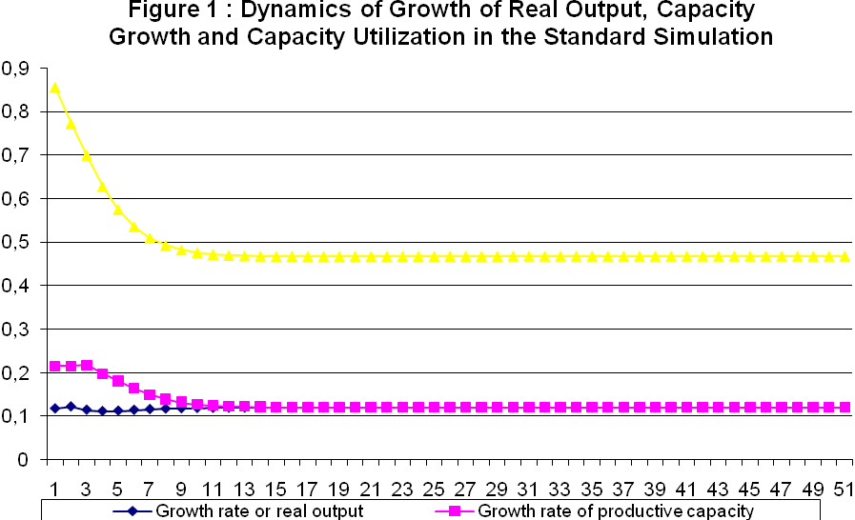

In the figure 1 above we can see that, for the values considered in the standard simulation, the selected variables converge to their long-run equilibrium values. In fact, growth rate of real output and productive capacity converge to their long-run equilibrium value of 12% p.p. Capacity utilization also converges to a long-run equilibrium value of 46.77% p.p.
The dynamics of short-term interest rate, inflation rate and short-run target inflation are shown in figure 2 below.
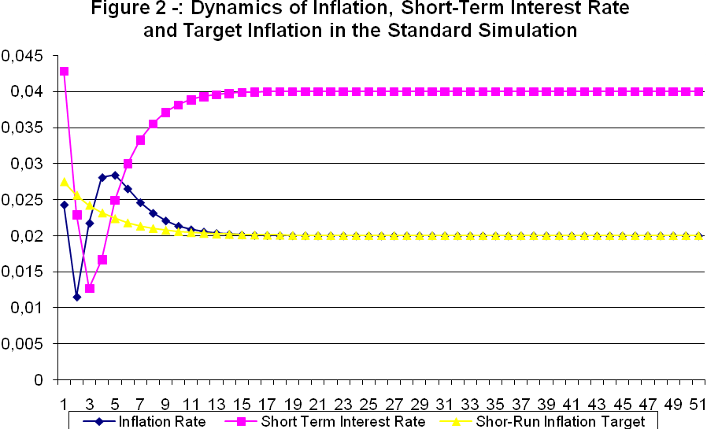

In figure 2 we can see that the selected variables converge to their long-run equilibrium values. In fact, nominal interest rate converges to its steady-state value of 4% p.p., given by the sum of the international interest rate (3% p.p.) and the risk premium (1% p.p.). We can see also the convergence of inflation rate to its long-run value of 2% p.p. Finally, we can see that short-run target inflation converges to the long-run target, which is equal to the long-run value for inflation rate.
We will now depart from the standard simulation in order to do two kinds of experiments. The first one will be testing the impact over the dynamics of the system of changes in the “structural” parameters of the economy, that is, in the parameters that reflect the level of productive specialization of the economy. The second one will be testing the impact over system dynamics off a change in “policy parameters”, that is, parameters that represent the monetary policy and the level of capital controls. The objective of these experiments is to evaluate the contribution of monetary policy and industrial policy for the promotion of a robust growth in the long-run, considering the existence of a demand-led growth regime.
In the first experiment we will consider an increase in the income-elasticity of exports from 1.5 to 1.65, that is, a 10% increase in the value of income elasticity of exports. This increase reflects the adoption of an industrial policy concerned with the reduction in the level of productive specialization of the economy at hand. The dynamics of the selected variables can be seen by means of figure 3 below:
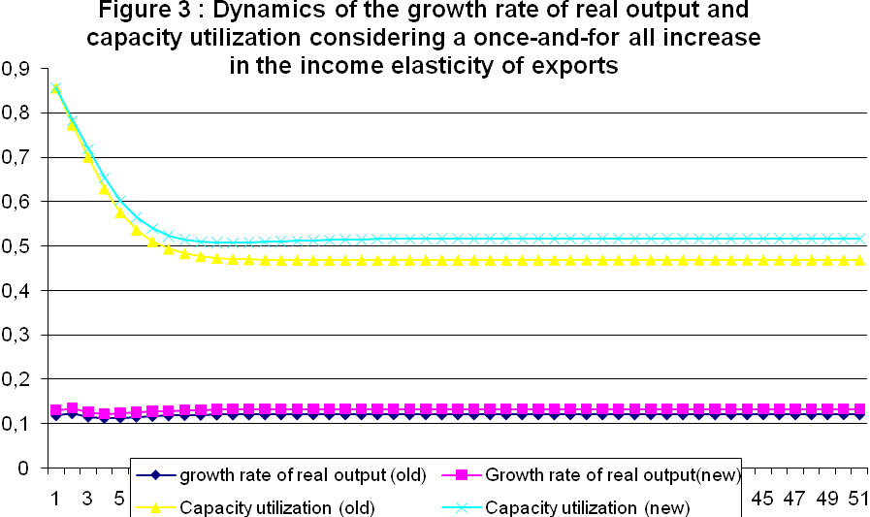

An increase in the income elasticity of exports has a clear effect over the long-run equilibrium value for the growth rate of real output and capacity utilization. In fact, as we can see in Figure 3, the growth rate of real output increases to a value of 13,2% p.p. In the standard simulation the long run equilibrium value for the growth rate of real output was 12.0% p.p. This means that a 10% increase in the value of the income elasticity of exports resulted in 10% increase in the long run equilibrium growth rate of real output.
In the second exercise we will consider an increase in the weight of output gap in the interest rate rule adopted by monetary authorities. More specifically we will suppose that θ₁ will be increased from 0.2 to 0.3, a 50% increase in the value of this variable. The visualization of the dynamics of the short-term nominal interest can be made by means of figure 4 below:
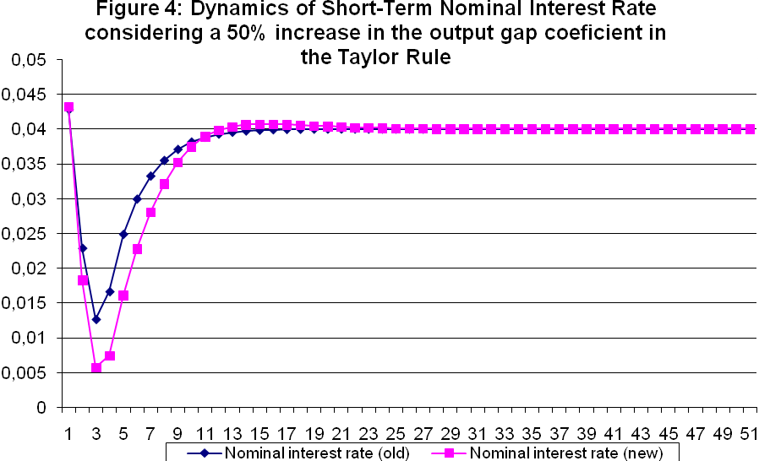

In figure 4 we can see two things. First of all, an increase in value of the output gap coefficient in the interest rate rule has no permanent effect over the short term nominal interest rate. This is a consequence of the fact that long-run equilibrium short term interest rate is independent of monetary policy in the economy at hand, being fully determined by international rate of interest and the risk premium. However, in the first 10 periods of the simulation, nominal interest rates are substantially lower in the dynamic path with a higher weigh for output gap in the interest rate rule. This means that this policy change have temporary, although long-lasting, effects over the short term nominal interest rate.
The effect of this policy change over the growth rate of productive capacity can be seen in figure 5 below.
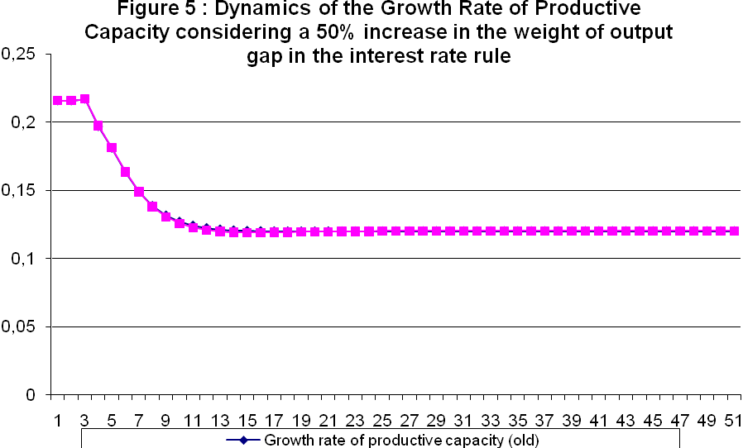
As we can see in figure 5, an increase of the weight of output gap in the interest rate rule has no permanent effect over the growth rate of real output. This means that monetary policy is neutral over long-run growth. This is a surprising feature of the model at hand given the Keynesian assumptions made about the structure of the economy. A possible explanation for this theoretical puzzle is that openness of capital account made nominal interest rate beyond the control of monetary policy in the long run. If this explanation is correct, financial globalization is responsible for long-run neutrality of monetary policy.
In the third experiment we will consider an increase in the level of capital controls, so that the sensitivity of the rate of change of nominal exchange rate to interest rate differential will decrease. More specifically, we will decrease the value of ε from -0.5 to -0.25. The impact of this change over the dynamics of the selected variables can be seen by means of figure 6 below:
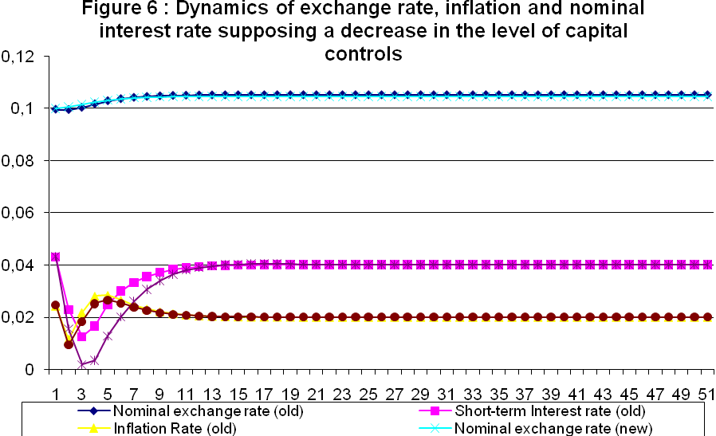
In figure 6 we can see that a permanent increase in the level of capital controls has only temporary effects over the levels of short term interest rate, inflation and nominal exchange rates. In fact, during the first 8 periods of the simulation (more or less 15% of the time spam of the entire simulation), a higher level of capital controls is associated with lower interest rate, lower inflation and lower nominal exchange rate. This means that a higher level of capital controls has ambiguous effects over real interest rate and it is likely to have no effect at all over the growth rate of productive capacity. From this reasoning we can conclude - in accordance with Ono, Silva, Oreiro and Paula (2005) - that the degree of openness of capital account is irrelevant for long-run growth.
In sum, the numerical simulations of the theoretical model allowed us to conclude that:
- The adoption of policies that aim to increase income-elasticity of exports create a clear increase in the long-run growth rate of real output. So there is a case for industrial policies to promote long-run growth. Industrial policies must be directed towards sectors and firms that produce tradable goods with a high income-elasticity of exports.
- The degree of activism in the operation of monetary policy, expressed in the coefficient of output gap in the interest rate rule, has no impact over long-run growth; so that monetary policy is neutral over long-run growth.
- Policies that aim to increase the level of openness of capital account do not have any impact over long-run growth rate of real output or over the long-run equilibrium value of nominal interest rates. The degree of openness of capital account is irrelevant for long-run growth.
5 – Real Exchange Rate, Income Distribution and Long-Run Growth.
In this section we will introduce the level of real exchange rate and income distribution in the structure of the model presented in section 3.
For such, we will consider the price equation and the real wage equation:
$p=(1+z)\left[\frac{w}{q}\right]$ (19)
$ω=\frac{w_{t}}{{\left(p_{t}^{e}\right)}^{δ}{\left(e_{t}p_{w,t}\right)}^{ε}}$ (20)
Solving (19) for w and substituting the resulting expression in (20), we arrive at the following equation:
$ω{\left[η\right]}^{1'−δ}=\frac{1}{1+z}$ (21)
Where: $η=\frac{{\text{ep}}^{}}{p}$ is the real exchange rate.
Due to the existence of real wage resistance there is an inverse relation between real exchange rate and the mark-up rate. This means that an increase in the rater of mark-up by firms will produce a real exchange rate appreciation.
Profit share (m) is determined by:
$m=\frac{z}{1+z}$ (22)
From (22) and (21) we can establish a connection between real exchange rate and income distribution between wages and profits by means of the following equation:
$ω{\left[η\right]}^{1'−δ}=1−m$ (23)
According to equation (23), an increase in profit share (i.e. a reduction in wage share) will produce, for a given level of real wages, a real exchange rate appreciation. Mutatis mutandis, a decrease in profit share will cause a real exchange rate depreciation. This result shows to us that variations in real exchange rate are non-neutral over income distribution between wages and profits.
We have argued that marginal propensity to import and exports multiplier depends on the level of productive specialization of the economy, which is, in turn, influenced by real exchange rate. In order to formalize these ideas, we will suppose that exports multiplier λ can be expressed by:
$λ_{t}=λ_{0}\left(\frac{e_{t−1}p_{t−1}^{}}{p_{t−1}}\right)$(24)
Equation (24) shows that a real exchange rate appreciation in period t-1 produces a reduction in exports multiplier in period t, since a real exchange rate appreciation induces an increase in the level of productive specialization and an increase in marginal propensity to import.
In the long-run equilibrium we have:
$λ=λ_{0}η$(24ª)
Solving (23) for η and substituting the resulting expression in (24a), we have:
$λ=λ_{0}{\left\{\frac{1−m}{ω}\right\}}^{\frac{1}{1−δ}}$(25)
Substituting (25) in (15b) we have:
$\hat{Y}={\text{γλ}}_{0}{\left\{\frac{1−m}{ω}\right\}}^{\frac{1}{1−δ}}{\hat{Y}}_{w}$ (26)
Equation (26) shows that long-run growth rate of real output depends on: (a) the growth rate of world income, (b) the profit share; and (c) the real wage rate. For a given rate of world income growth, an increase in the profit share will produce a real exchange rate appreciation that will induce a structural change in the economy at hand, producing an increase in the level of productive specialization of the economy. This will produce an increase in the level of marginal propensity to import, causing a reduction in the level of exports multiplier. As a result of this structural change, long-run growth rate of real output will be decreased.
In order to analyze the relation between profit-share and the level of capacity utilization we will substitute (25) in (16b). We get the following expression:
$u=\left\{\left(\frac{ϕ_{2}}{ϕ_{1}}\right)\right\}{\hat{p}}_{w}+\left(\frac{{\text{γλ}}_{0}}{{\text{σϕ}}_{1}}{\left[\frac{\left(1−m\right)}{ω}\right]}^{\frac{1}{1−δ}}\right){\hat{Y}}_{w}−\left(\frac{ϕ_{0}}{ϕ_{1}}\right)−\left(\frac{ϕ_{2}}{ϕ_{1}}\right)\left(i_{w}+ρ\right)$ (26)
From (26) we can easily see that an increase in the profit share will produce a reduction in the level of capacity utilization.
The results presented above show that an increase in profit share will cause a reduction in the long-run growth rate of real output and also a decrease in the rate of capacity utilization. This means that the accumulation regime of the economy at hand is of wage-led type. This is a surprising result in face of the fact that exports are the main source of demand growth for the economy at hand.
A policy conclusion that can be obtained from the model is that economic policies that aim to increase the long-run rate of output growth must be directed towards an increase in the wage share.
6 – Conclusions.
Though out this article, we have presented a modified Kaldorian model of demand led growth in order to analyze the effects of ITR and real exchange rate appreciation over long-run growth. An important result of the analysis made here is that the existence of a balanced growth path for real output requires a flexible long-run target inflation, that is, a long run value for target inflation that is adjustable to the international rate of inflation.
Another important result is the long run neutrality of monetary policy. This is a surprising result given the Keynesian assumptions about the structure of the economy. A possible explanation for this theoretical puzzle is that integration of financial markets all over the world makes short term interest rate a variable that is beyond the control of monetary policy.
It is also shown that the degree of openness of capital account is irrelevant for long-run growth. This means that liberalization of capital flows will not help to increase the rate of economic growth. The acceleration of growth requires the adoption of industrial policies that aims to increase the income elasticity of exports.
Finally, we saw that real exchange rate appreciation will produce a reduction of the growth rate of real output and the rate of capacity utilization in the long-run. Since there is an inverse relation between profit-share and real exchange rate, this result suggests that policies that aim to increase the long-run growth must be directed toward an increase in the wage-share.

REFERENCES.
BARBOSA, F.H. (2004). “A Inércia da Taxa de Juros na Política Monetária”. Ensaios Econômicos N° 534. Fundação Getulio Vargas: Rio de Janeiro.
BARIAN, E. (1997). “Levels of Economic Development and Appropriate Specification of the Harrod-Foreign Trade Multiplier”. Journal of Post Keynesian Economics, Vol. 19, N.3.
Carvalho, F.C. (1992). Mr Keynes and the Post Keynesians. Aldershot: Edward Elgar.
DAVIDSON, P. (1999). “Global Employment and Open Economy Macroeconomics” In: DEPREZ, J; HARVEY, J. (orgs.). Foundations of International Economics. Routledge: Londres.

DUTT, A.K (2003). “Income elasticities of imports, North-South trade and uneven development” In: DUTT, A.K. ROS, J. (orgs.) Development economics and Structuralist Macroeconomics. Edward Elgar: Aldershot.
DIXON, R.J; THIRWALL, A.P. (1975). “A model of regional growth-rate differences on Kaldorian lines”. Oxford Economic Papers, 27.
DOMAR, E. (1946). “Capital Expansion, Rate of Growth and Employment”. Econometrica, vol.14.
DOSI, G; PAVITT, K; SOETE, L. (1990). The Economics of Technical Change and International Trade. Macmillan Press: London.
HARROD, R. (1939). “An Essay in Dynamic Theory”. The Economic Journal, vol. 49.
KALDOR, N. (1988). “The Role of Effective Demand in the Short and Long-Run Growth” In: Barrére, A. (org.). The Foundations of Keynesian Analysis. Macmillan Press: London.
KEYNES, J. M. (1936). The General Theory of Employment, Interest and Money. Macmillan: London.
LEDESMA, M.L; THIRWALL, A. (2002). “The Endogeinity of the Natural Rate of Growth”. Cambridge Journal of Economics, Vol. 26, N.4.
MADDISON, A. (1991). Historia del Desarollo Capitalista. Ariel, Barcelona.
McCOMBIE, J.S.L; ROBERTS. (2002). “The Role of the Balance of Payments in Economic Growth” In: SETTERFIELD, M. (org.). The Economics of Demand-Led Growth. Edward Elgar: Aldershot.

ONO, F.H; JONAS, G.; OREIRO, J.L; PAULA, L.F. (2005). “Conversibilidade da Conta de Capital, Taxa de Juros e Crescimento Econômico: uma avaliação da proposta de plena-conversibilidade do Real”. Revista de Economia Contemporânea, Vol. 09, N.02.
PALLEY, T. (2002). “Pitfalls in the Theory of Growth: an application to the balance-of-payments-constrained growth model” In: SETTERFIELD, M. (Ed.). The Economics of Demand-Led Growth. Edward Elgar: Alderhot.
-------------- (2006a). “Monetary policy in an endogenous money economy” In: ARESTIS, P; SAWYER, M. (Eds). A Handbook of Alternative Monetary Economies. Edward Elgar: Aldershot.
________. (2006b). The economics of inflation targeting: negatively sloped, vertical, and backward-bending Philips curves, manuscript.
ROBINSON, J. (1962). Essays in the Theory of Economic Growth. Macmillan Press: Londres.
Rowthorn, R. (1999). Unemployment, capital-labor substitution and economic growth. IMF Working Paper WP, No. 99/43.
SETTERFIELD, M. (1997). Rapid Growth and Relative Decline. Macmillan Press: London.
------------------------ (2005). Is inflation targeting compatible with Post Keynesian economics?, manuscript.
SOLOW, R. (1957). “Technical Change and the Aggregate Production Function”. Review of Economics and Statistics, Vol. 39.
TAYLOR, L. (1989). Macroeconomia Estruturalista. Cidade do México: Trillas.
THIRWALL, A. (2002). The Nature of Economic Growth. Edward Elgar: Aldershot.

We have to notice that the importance of aggregate demand for long-run growth was emphasized by other Keynesian authors before Kaldor. In the growth model of Joan Robinson (1962), for example, the growth rate of capital stock is determined by the interplay between propensity to invest of capitalists (determined by their animal spirits) and the propensity to save out of profits. An increase in the propensity to save out of profits will produce a reduction in the desired rate of accumulation, showing the fundamental importance of aggregate demand for long-run growth. However, it remains the idea that the availability if means of production sets an upper limit for long-run growth. In fact, the growth rate of the labor force is considered an exogenous variable in the system and can set an upper limit to economic growth since the economy could not grow indefinitely at a rate bigger than the one allowed by the expansion of the labor force (adjusted by technical progress) In 1988 article, Kaldor argued that, in the long-run, the growth rate of labor force is not independent of demand, but adjusts itself to the growth of demand for labor.
Some empirical evidences about the validity of these classes of models must be obtained in Ledesma and Thirwall (2002) and Thirwall (2002).
See Dixon and Thirwall (1975) and Setterfield (1997).
Where: $u_{t}=\frac{Y_{t}}{{\bar{Y}}_{t}}$is the level of capacity utilization in time t.
In other words, long term interest rate will be the sum of short term rate and a constant liquidity premium.
For an open economy with capital mobility, the long-run equilibrium level for nominal interest rates is given by the sum of international interest rates and risk premium, instead of being the level of nominal interest rate that, for a given rate of inflation, equalizes aggregate demand and capacity output.
For a detailed explanation of the effects of financial globalization over the efficiency of Keynesian demand policies see Davidson (1999). According to Davidson, expansionary fiscal and monetary policies will only be effective in producing a robust growth for world economy if a severe prohibition of speculative capital flows was adopted through out the world.
An empirical study about the determinants of the income-elasticity of exports and imports can be found in Barian (1997).

