Brazil’s economy - 1971-2005: growth pattern and structural change

RESUMO

O objetivo do texto é analisar diferentes regimes de crescimento da economia brasileira a partir dos anos de 1970 até 2005, considerando as flutuações do investimento e da produtividade como determinantes. Identificamos e qualificamos diferentes fases ou caminhos de crescimento compondo uma trajetória de longo prazo. O comportamento oscilatório dessa trajetória tem sido atribuído a regimes diferentes, determinados por mudanças nas políticas econômicas e seus efeitos sobre a estrutura produtiva via mudança estrutural induzida. Apoiados na visão kaldoriana e neo-schumpeteriana introduziremos o Framework Space como instrumento de análise da dinâmica da trajetória de crescimento econômico do Brasil.

Palavras chave: Crescimento Econômico, Mudança Estrutural, Investimento, Produtividade.

ABSTRACT

The aim of the paper is to explain the growth pattern of the Brazilian economy during the 1971-2005 period as a sucession of phases that are identified and described according to qualitative characteristics associated with historical events. Additionally, we show that the transition from one phase to another is explained by alteration in the economic environment and/or changes in policies that put in march structural changes. In this sense in the proposed analysis growth pattern and structural changes were both identified and analysed.

1 – Introduction

Growth cycles are well documented and studied phenomena in the LDCs, in the case of Latin America they are often related to the evolution of the conditions of international liquidity (Amado, et al 2007). But, in general, growth in such countries tends to be less stable than in developed ones, as those economies are often constrained by a variety of domestic and international constraints, among them Balance of Payments constraints. This has been true also of our case study hereafter, the Brazilian economy: at the beginning of the 1960s and in the 1980s, and again, more recently, during the second half of the 1990s following the financial crises of Mexico in 1995, Asia in 1997, and Russia, in 1998. The unfolding of the current major crisis will surely offer more evidence urging a fresh reflection on comparative growth dynamics.

One way to try to overcome such constraints and sustain growth is through changes in the very structure of their economy. These changes would show up in the associated pace of growth dynamics. Such fundamental adjustments may be “spontaneous” (or shock-induced); at times, though, they are the result of policy decisions. The industrialization process via import substitution in Latin American countries is a clear example of the latter. Either way, new challenges arise to sustain further growth.

This interaction between structural and adjustment dynamics (with their driving forces) may account for the varied landscape offered by the world’s (and LDC’s) experience of growth. Established theories offer an equal varied set of explanations. Neoclassical theory, together with the relatively more recent endogenous theories, indicate conditions determining the rate of growth of an economy’s long run as well as its shorter term varying pace. Thus, differences cross countries in the pace of output and productivity growth, or between periods in the history of a given country or region, are basically accounted for in terms of demographic dynamics along with capital accumulation and technical progress. Certain nonlinearities and/or the redefinition of variables (e.g. to include human capital, etc.) make the distinction of exogenous from endogenous theories. Among the latter, the latest vintage introduces the notion of innovation as a growth engine (see the classic Aghion and Howitt, 1998)). However, all such theories share a long run horizon to justify their concentration solely upon the conditions of supply.

Constraints deriving from the demand side, in other words, are not considered as equally relevant in such time horizon. The reason for such failure, as offered by e.g. Thirwall (2003), is in that both production factors and, often, also technical progress are seen as resulting from basically non economic processes. However, it can be argued that the growth rate of labor force, capital accumulation and technical progress may depend, to a large extent, on the growth rate of aggregate demand that, in turn, may depend, among other things, on the short run governance of economic policy. (see e.g. León-Ledesma and Thirlwall, 2002 and Libânio, 2008). An approach that returns a place to aggregate demand, offers an important perspective upon the interaction between the short run of historical events and the implied long run growth performance.

While the growth cycles described in the literature may take such factors into account, so far they failed to capture the discontinuities that interaction with other variables induces or renders possible. Such interdependence surely contributes to generate and thus to explain observed irregularity and “regime” instability as we will define it.

Thus, our aim in this paper is to explore the qualitiative features and the articulation of the growth experience of the Brazilian economy in the last 35 years, consideration given also to the role played by aggregate demand and its determinants. It is our hypothesis that economic policies exert an important role in the growth process via their direct and indirect influence upon demand. The interplay between short/medium run dynamics and the economic forces ruling the long run generally is such as to produce a non linear growth pattern, that is to say, a pace of growth that neither necessarily converges towards a pre-determined equilibrium position, nor is it smooth. Our rejection of the basic double prediction of standard theory, leads to consider the changes in the current growth path that (may and often do) trigger structural changes: qualitative changes implied by discontinuities in the economy’s “model of growth”.

This paper takes the recent history of the Brazilian economy as a case study to highlight the role of structural oscillations. As a key component of the history of an evolving economy, they represent the fundamental shape a country’s growth experience takes up.

2. – Brazil before and after the 1980s

Since post-War until the beginning of the 1980s Brazilian economy grew above the average of developed and underdeveloped economies, showing a strong vigour under the leadership of the manufacturing sector. This result can be explained in a great deal by the strategy of import substitution to complete the industrialization process of the country. As quoted by Serra (1982, p. 6) between 1949 and 1970 manufacturing sector increased its participation in National Income from 20.2% to 27.3%. The main industrial sectors to explain such performance were the production of capital goods and durable goods. However, such deep transformation in the productive structure came together with macroeconomic unbalances. So, an important feature of the import substitution strategy followed by the country was the increase dependency of foreign capital to finance growth, generating recurrent Balance of Payments problems. Also chronic and high inflation has always been present in the Brazilian economy. Following the structuralist interpretation it was the result of the speed and intensity of the transformations in the productive structure provoked by rapid industrialization.

The comparatively slow growth of the Brazilian economy since the 1980s (and compared to other emerging countries) have been the subject of major concern, and often seen as a real puzzle, among policy makers and researchers. According to Bacha and Bonelli (2005, p. 163), for instance, the deceleration after the 1980s is “A mystery [that] surrounds Brazil’s long-term growth experience”.

Indeed, it is well known that the Brazilian economy experienced accelerated growth since the end of the II World War until 1980 (6.4% aa)). In the industrial sector alone, the 1970s registers the highest rates (7.4% aa), even slightly higher than those of the whole economy. It is, this, the time period where the industrialization process via import substitution comes to maturation. (Graph 1).

Such “success story” was interrupted by the debt crisis in 1980-81, which imposed external financial constraints to the development strategy implemented since mid 1970s.Therefore, it makes sense to speak of phases in the growth experience of the Brazilian economy, as at least two if not more (major) phases can be identified, and such organizing notion has indeed repeatedly appeared in the literature. Just to mention two exemples of classification for comparison, Bacha and Bonelli (op.cit.), have six such phases for the period 1940-2002 while Castro (2008), on the other hand, has 4 since the 1980s.

Graph. 1: Real growth rates: GDP and Manufacturing Industry Value Added (%)
1948-2007
Source: National Accounts.

In this paper, we also propose to analyze the country growth experience, starting from 1971, as a sequence of distinct phases. In doing this, however, we also take into account explicitly the profile of the process of capital accumulation (see Graph. 2).

Like in other authors, our breakdown is determined by our own assessment of key events and perception of their insertion in a historical evolution. The following analysis will have to justify itself by showing that each phase identified displays distinctive features in the light of our emphasis on the role played by structural adjustments and similar abrupt changes. This qualitative analysis is meant to reconstruct what we call a growth pattern.

Graph 2: Rate of investment as percentage of GDP
1971-2007
Source: National Accounts

In fact, the qualitative dynamics of such phase sequence, with the dynamics within each phase concatenated with the dynamics across two time-adjacent periods, represent the dynamic pattern of an economy’s growth. Such a notion synthesizes those aspects that set a given country’s growth experience apart from that of others and motivate the time-long effort, well documented in a vast literature to capture the phenomenon of dynamic variety. Therefore, we see our net contribution to an already rich literature in reconstructing such pattern. Our focus will be upon the specific time-articulated Brazilian experience, with phases each distinct from one another but concatenated.

3. Introducing the Framework Space device

The conventional approach assumes, implicitly, that actual economies tend in the long run to a determined path (a single state), belonging to a stable regime, and that such a state is so strong attractor that any shorter run dynamics is practically irrelevant, as transient motion. However, observed data appears to be fluctuating all the time. Thus, variability has to be retained and it also has to be evaluated against the dynamics of related variables. Thus, as good as it may look, this prediction does not account for the manifold dynamics that can be observed in real world economies and in their histories (see Böhm and Punzo, 2001), and Gaffard and Punzo, 2005). It is to deal with this issue, that the Framework Space (FS) incorporates a whole menu of growth models. It is from such menu that are constructed actual patterns of growth.

The FS is an analytical device to focus on variables such as capital accumulation, employment and productivity. The primary justification for such a choice is, of course, that these are the variables of growth theories as we know them. The FS has only the rate of growth of investment per employee (on the vertical axis) and the rate growth of labor productivity (horizontal axis). The aim of their choice is to explain the relation between the dynamics of the fluctuations in productivity vis-à-vis the dynamics of the fluctuations in investment per employee.

One can relate the FS to predictions of the conventional theories in a simple way. E.g. neoclassical theory (NC) views a unique global attractor which is a steady state path with growth rate g_{NC} defined as:

$g_{\text{NC}}=n+λ$

(where both the rate of growth of population n and technical progress $λ$ are parameters). We may associate such given value with a point on a real-valued line - the line of growth rates indexing feasible paths of output or else GDP. To take into account the parallel process of capital accumulation, a vertical accumulation axis is considered, the intersection of the two defining the origins of the growth plane, contraction being defined as negative growth.

Now, the FS is obtained from the growth plane by, first, redefining the coordinate system. In fact, shifting the origin to the exogenous value λ = (g_{NC} – n), the growth line becomes the (labour) productivity axis. As its origin is associated with the exogenous rate of growth of productivity, any other point is a candidate endogenous rate of productivity growth (with the corresponding path), or else (as is in the neoclassical interpretation) it is associated to transitory dynamics. The FS coordinate system is completed by adding a new vertical axis associated with the rate of growth of investment per employed. This is the capital deepening axis, naturally going through the origin of the productivity axis. Outside the origin, capital accumulation may be a determinant of productivity dynamics. Other factors may, however, exert a key influence, whose effects are all lumped together into the broad category of innovation.

As such, the FS is a heuristic device, which can be best employed in classifying empirical phenomena and to trace interpretations back to inherited theories. The FS allows to associate certain episodes or even whole phases in the actual history of a country, with existing interpretations. We have already seen the kind of path(s) predicted by the NC theory. On the other hand, the Keynesian tradition in the Kaldorian version, on the contrary, assumes technical progress to be incorporated, investment in fixed capital being its privileged vehicle. Thus, productivity will increase the faster is the process of capital accumulation, while, instead, the neo-Schumpeterian view explains growth (as output and productivity advances) on the basis of innovations, whether new organizational forms or processes, or else the introduction of new products that increase the gap between unit costs and the final price. Neither investment, nor technical progress would account by their own for an economy’s performance. The three views are quite distinct, and therefore well representative of a broad spectrum of minor variations.

Those theories can be associated with partitions in the FS (Figure 1). There, a special set of paths (the 45º line) called the Harrodian corridor separates Regime VI (where accumulation leads ahead of productivity growth) from Regime I where the opposite takes place. Conventionally named the accumulation and the innovation regimes, respectively, these two jointly span the growth quadrant. Dually, Regimes III, IV span the contraction quadrant. We can argue that those two quadrants encompass all predictions of growth theories. We have two remaining quadrants that may turn out relevant in analyzing actual histories, hence along a shorter time horizon. For lack of a better, theory-based term, they are referred to as Restructuring Regimes.

So we define as a growth regime a set of equations describing dynamics taking place locally when the economy is in a set of states. In the FS, therefore, an economy’s actual trajectory (its historical growth experience) is sequenced as a string of growth paths, some lingering for some time within a regime; otherwise, going across regimes. When this happens we talk of regime changes or switches, and we feel entitled to take such jump or discontinuity as the manifestation of an underlying structural change, rendered explicit by certain qualitative aspects of the economy’s observed dynamics. The latter therefore has a variety of possibilities to offer. Hence, while a trajectory is any generic sequence of growth paths, a growth pattern is the distilled representation of the trajectory’s qualitative features through the properties of its regime (or coded) representation (Brida and Punzo, 2003).

Therefore, whilst multi-regime dynamics may claim to include all sorts of familiar dynamics, together with its FS visualization it has a value added: it gives a representation of an economy’s capability of evolving over time as a journey through growth models.

Combining these relatively novel notions with a predetermined historic segmentation into phases, we get a rich scenario. Within a given phase, we may find a stable regime, or one or repeated switch from one to another (or others). We may encounter a single crossing from one regime to another, this resembling very much what we think of as structural change, a one-directional, irreversible event..However, an orderred sequence can be detected named structural cycles. Such mayor cycles, compared to those that may, and often do, take place within a regime, become interesting when they reveal the presence oa a concatenation mechanism. The same complex dynamic variety can emerge when we look at the concatenated phases. Such concatenation is the growth experience we want to examine.

Figure 1: Growth regimes in the FS

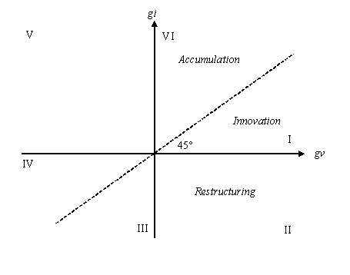

Looking at a country’s economic history as a structured sequence of regimes, affords a new view.

5. Historical events delimiting growth phases of the Brazilian economy

As said, since World War II, at least two phases can be identified: before and after 1980. However, (hyper-) inflation has always been a structural problem in Latin American compared to developed economies. It was in Brazil: from 1971-1981 the annual rate of inflation was 44.6%, against a growth rate of 7.4%. Thus, making room in the stage behind the FS, for the rate of inflation as a key variable to qualify growth trajectories, we can further break down the time period after the 1980s. Accordingly, we divide the time interval into: a 1981-1994 phase characterized by high inflation (over 500% aa) associated with low growth (2.4% aa); a second phase (1994 to 2002) where a still low growth (2.3% aa), was associated with controlled inflation (12.3% aa), and finally the phase from 2002-2005 with inflation under control (6.9% aa) and a relatively superior growth performance (3.3% aa). (The phases are represented in Graphs 4 to 7).

5.1 –Growing across phases: a bird’s eye view of the FS

Before presenting the individual FS pictures of the four phases we just defined and, thus, before discussing the distinct dynamic behaviors emerging therein, it is worth having a quick look at the “average” performance of the economy as such and of its industrial sector.

Graph 3 shows a remarkable feature of Brazil’s performance, at least as far as industry is concerned: a stable qualitative behavior appears to have prevailed in the first three phases, all growth paths lying in the accumulation regime (VI). A dynamic discontinuity- in our words an episode of structural change- occurs only at the junction of the third with the last phase. At that time, the path of the economy’s industrial sector jumps into the innovation regime (I). We supplement information to account for such aggregate pattern.

In the first phase, basically coinciding with the 1970s, (no.1 in Graph 3) growing investment per employed (capital deepening with increasing equipment per unit of operative) reverberated in (or “immediately generated”) a process of increasing labor productivity, a phenomenon well known in the literature. While the 1980s saw a sharp decline in the levels of employment, the rates of growth of investment remained relatively high, thus fostering capital deepening though at a slower pace in the 1970s (point no.2). The commercial opening of the 1990s exposed Brazil to a positive supply shock, access to better quality inputs resulting in a net productivity growth effect (above the accumulation pace). Nevertheless, this decade and the start of the new century did not show on the whole the expected industrial dynamism, as the recovery of efficiency (in terms of labour productivity) only occurred against a backdrop of slow growth. (IEDI, 2005). This however led Brazil’s industry (and the whole economy) to the edge of the Harrodian corridor (no. 3 in Graph 3), ready for a further jump forward (or a fall back).

With the strong exchange rate ruling from 1995 to 1998, the devaluation in 1999-2002 and the new currency appreciation in 2003, a regime shift had to occur in the last phase, and it did occur. Whereas currency devaluation were increasing costs as import input bills, appreciation, due to the valuation in commodity prices from 2002 onwards, gave a boost in exports of the Brazilian industry specialized in the production of commodities. Industry could only keep growing by “going innovative”(mainly in process). The result was a pace of productivity growth faster than that of capital accumulation (no. 4 in Graph 3). The point to highlight is that as investment rate did not show a significant recover, productive growth was lower than the observed rates in the 1970s. On the whole, observed growth relied on a favorable external scenario, commodity prices being a major actor redressing the external and domestic balance of the economy, while the industry did not seem to pursue an expansion plan via adding new productive capacity and further diversifying its productive structure. Thus. growth was basically driven by what we have termed innovation activities, and it followed a process which probably could only deliver its ripe produce in the following, present phase.

Graph 3:the four phases at a glance- 1971-2005

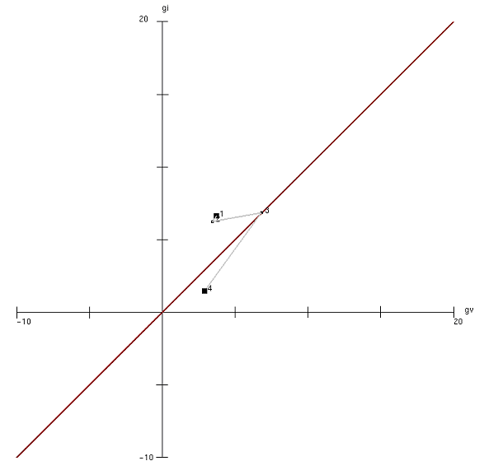

In sum, as a late comer in the industrialized world, the Brazilian economy shows great dynamism since II World War, boasted also by State interventions pro-industrialization. The debt crisis in the 1980s brought this process to a halt, and ushered in high inflation with slow growth. Only a well coordinated economic policy can overcome a high inflation regime (Feijo and Carvalho, 1992). This was the main issue during the 1980s until beginning of the 1990s. The long fight to control prices, most of the time in an environment of external constraints, had a strong influence on the decision making process of the private sector, with consequences on growth. The opening of the economy and the neo-liberal orientation of the economic policy since the 1990s created new challenges for the private sector.

We are ready for the analysis of the individual phases. Most of what will be said hereafter will be referred to the dynamics of Brazil’s industry, but qualitative features composing the pictures of multi-regime dynamics mirror those of the economy as a whole.

5.2 – High Growth: the minor cycle of the 1970s

We can accompany the pictures in the FS with the chronology of relevant events. Thus, Brazil’s economy and its industry enter the 1970s in the middle of the economic miracle, generated after the 1964 policy measures, which meant increasing demand and thus output of (durable) consumer goods, and savings, associated with the increasing purchasing power of a newly born and slowing growing middle class. Productivity growth was remarkable, probably as the delayed result of industrial changes and investment realized earlier on. The start of the 1970s was marked by a structural shift, which Graph 4 shows as the switch from the “innovation regime” (then, a growth path with low investment and high labor employment) to the accumulation regime with labor productivity growing at a slower pace than investment per employed. This coincides with the picture of years 1970s we find in the literature, which attributes the jump to the oil shock (it actually takes place between 1973 and 1974, the shock being December 1973) and Government (President Geisel’s) reaction inducing a forced growth. This “pegged” the economy down in accumulation regime throughout the phase, a good example of a stable regime with oscillations from path to path within it (or small oscillations). Finally, phase and prevailing regime practically coincide.

However, compared with the vision of the four phases together of Graph 3, we now see interesting changes in pace: it slowly picks up from 1972. Once realized the regime switch, with the new development policy swiftly put in place, there is a minor cycle driven basically by investment dynamics, occupying the remaining years of the 1970s. This may reflect a number of factors, among them the technical complementarities in production that generate time lags between investment and productivity results, as well as the adjustment in investment plans and public policies. The stability of the accumulation regime shows the already noted reinvigorated policy of import substitution privileging capital goods and infrastructure; as much as the stability of the innovation regime up until the oil shock exhibited the strength of the earlier consumption promoting policies. Perhaps influenced by the events in the developed countries, the literature sees the remarkable episode of the phase in the end of the miracle in 1973-4 (emphasizing the fact that it might also mark the beginning of the new democratization process). In fact, the oil shock only brings about a change of policy, initiating a new, well defined loop driven by accumulation in the capital good sectors. Such cycle ends with the episode of the 1981. Still, this does not lead out of the prevailing regime, this takes place the next phase, which is therefore marked precisely by this event.

Graph 4: the minor industry’s cycle of the 1970s (1971-1981)
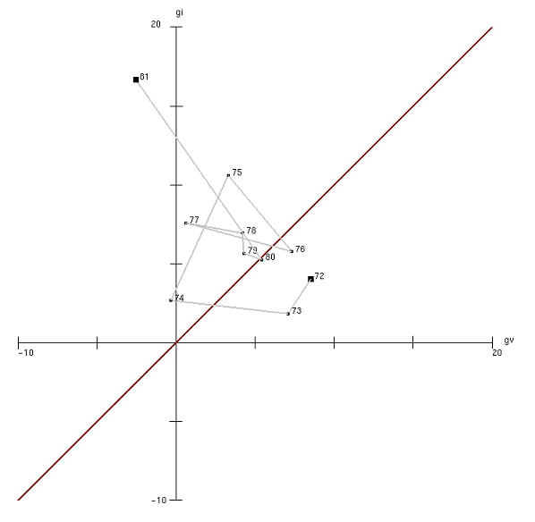

Thus, we find confirmation that this initial phase was marked by the two National Development Plans (PND I and II). Reflecting a growth strategy drawn up by a government staff with a development-oriented outlook, they privileged durable goods sectors, an attention later extended to all sectors producing capital and intermediate goods as well as infrastructure (hence, the very high investment rates throughout this and part of the ensuing phase). Deep changes in the productive structure of the manufacturing industry, notwithstanding the overall stability of the prevailing regime, took place, paving the road for a possible new growth path, which however was not to materialize, due to external and internal reasons.

The first oil shock decelerated the growth rate of GDP and industrial output, of course, but it did not impair investment plans as government policies supported continued import substitution and international liquidity provided plenty of finance. Actually, the picture shows an acceleration of such process. The second oil shock and the sudden hike in international interest rates in 1979 undermined this idyllic growth trajectory, and opened to its largely unexpected conclusion.

5.3 – The shape of the Big Crisis and its end: the structural cycle of 1981-1994

The FS shows that the descent from the high growth path of the 1970s was not simply a quantitative adjustment. It required, to get realized, a major process with concatenated episodes of structural change.

Structural change takes time to accumulate enough energies to become visible as a discontinuity, whether we conceive of it, more traditionally, as a resource reallocation process, or as a change in the model of growth, as we do here. This feature shows up clearly in Graph 5 which exhibits various episodes of regime switches taking place in and actually being the regime instability characteristic of this second phase (compared to the earlier stability).

As just anticipated, the phase kicked off in the accumulation regime inherited from the preceding phase and it did linger there for a couple of years at the beginning. It is in 1984 that it changed over to an innovation regime (confirming Castro, 2008, sub-periodization), associated with the superavit episode of the 1983 (to which it were to be return only in the final years before the next phase). Since then, to the early 1985, we see the unfolding of Castro’s marcha forçada (Castro and Pires e Souza, 1985), as they appear to be rather the conclusion of a structural cycle initiated with the II Plan, and the beginning of a new story: the 1985 has a new Sarney’s government and then the 1986-7 shows the immediate effects of its political measures: price and wage freeze, the moratoria of the external debt (only later, 1990, to be followed by the temporary freeze of the domestic debt). While the 1986 marks the definite failure of the Plano Cruzado (and perphas Sarneys’s political project), it also seems to induce a renewed development cycle, but very much constrained by the unsucessful measures to curb down inflation. After a slow start (the loop 1987-89), it picks up and leads from a period of sustained capital deepening to increasing labour productivity. This sub-cycle shows the time complementarity between investment and productivity and retraces, though positively, the free fall path of investment and productivity that characterized the uncertain initial part of the phase. It is concluded by the 1994, the Plano Real, with the new Cardoso Presidency.

Thus, compared with the previous and the following ones, this phase is characterized by a major structural cycle (a cycle including at least one regime switch), taking industry as well as the Brazilian economy to repeatedly visit the accumulation and the innovation regimes, while comprising a dash into contraction (which appears as the episode of the 1986), as a deepening of a restructuring situation of the 1985, which is part component of the process of contracting both investment and productivity initiated in the 1984. There is a minor cycle in the accumulation regime, showing the natural instability of the second half of the 1980 following and associated with the dramatic price process of those years, deeply affecting investment returns prospects. The major cycle sets in really in 1984 to end ten years later, with the Plano Real. What the picture does not show, is that the industry and the economy exiting the cycle have nothing to do with the industry and economy they were at the beginning. This can only be seen in a finer picture, a detailed FS of the sectoral composition of the economy. We can only see what they will accomplish in the next phase.

Detailed interpretation is quite easy. The accelerated growth in the 1984-86 spell was unsustainable due to the spiraling inflation after the failure of the Plano Cruzado. After that turning point, inflation became the main obstacle to growth, threatening the sustainability of the rates (and levels) of fixed capital investments in the ensuing years, a situation that would only end in 1994 with the Plano Real.

After 1982 till 1994, growth becomes highly unstable. From 1987 to 1992 it is driven by the accumulation process, though at a slower pace than in 1971-1981. In 1984-1985 and again in 1993-1994, on the contrary, it was being driven by innovative activities generating productivity gains without a corresponding increase in gross fixed capital formation (relative to employment expansion). The 1986 was an atypical year, marked by the Plano Cruzado, the first heterodox attempt to fight inflation, which for a short period of time produced a sharp increase in consumers’ purchasing power as a result of the sharp drop in inflation. Between 1993 and 1994, the economy was opened and monetary stability finally achieved. These years mark the tail of the phase, opening into the next one.

To synthetize, this phase is dominated by a major cycle, a cycle that involved (repeated) crossing from one regime to another. Moreover, for the first time the regimes of restructuring and of deep restructuring were visited, and this can be compared to what happened elsewhere (Gaffard and Punzo (2005). Brazil in its own way partook of the global instability of the 1980s, reflecting major worldwide structural adjustment delayed after the end of the golden era of the post World War II years. Rising inflation and external difficulties, caused by the external debt crisis at the start of the decade, prevented the economy from continuing to grow as it had in the previous phase. Rates of per capita investment fell compared to their values in 1971-1981, as did GDP growth and employment. This led to stagnating productivity in the 1980s. At the start of the 1990s there was a broad process of productive restructuring in Brazilian industry because of economic opening. Brazilian industry was exposed to a more competitive environment. Introduction of innovations (possibly linked to the opening to international markets and progressive integration) and a deep impact of new technologies are deemded to account for growth of industrial productivity in the 1990s, although rates of investment rate did not recuperate its former levels.

Graph 5: the major cycle in between decades – 1981-1994

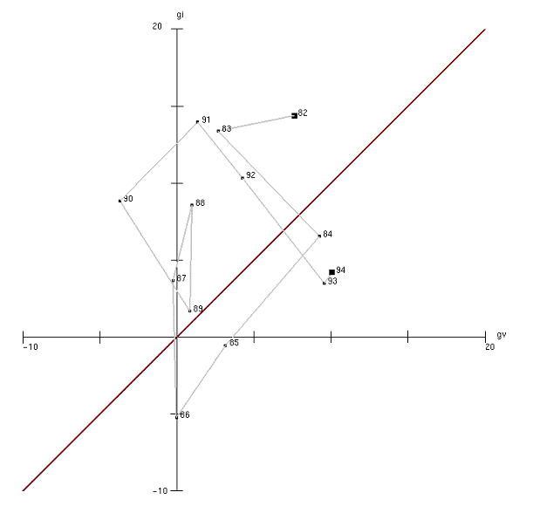

5.4- Dwindling growth in the era of economic reforms: 1994-2002

A stop-and-go set of economic policies was to meet the challenges created by the crepuscule of the second phase and left over to be sorted out in the next. They also unfortunately marked the key characteristics of the third phase of growth, denoting the tentative search for solutions and new models of development for the economy and its industry. These were correlated with the new economic reforms that the new Cardoso Government stubbornly pursued. Their desired and undesired effects are punctually reflected in the corresponding picture which shows an economy searching for an equilibrium path (Graph. 6). The cycle begins with the 1994 currency reform (which ends with hyperinflation) to end with the exchange rate crisis of the 1999. What follows seems rather adjustment to the day to day shocks the economy (with the world economies) was passively receiving.

They are very clear in the dispersion of the annual growth paths in the FS, drawing an irregular trajectory of dwindling growth, along the Harrodian corridor with casual invasions into one or the other regime. Again, a cycle with regime switching seems to prevail, though its agglomeration around the Harrodian corridor hardly qualifies as a structural cycle: the repeatdness of the switches together with the small size of the jumps is probably the mark of those sudden changes in extemporaneous policy decisions. On the other hand, they probably reflect the counterbalancing effect, in the private decisions, of policy and international uncertainty with the new experience of price stability. We are in for the historical facts.

Between 1995-1997, growth was coupled with increasing productivity, probably still an effect of commercial opening and privatization. Then, during 1998-1999, there was a change in growth regime, fact that may be attributed to the international liquidity crises that occurred in this interval. The reversal of international capital flows prompted the government to adopt contractionary monetary and fiscal policies to defend the country against the rapid drying out of foreign exchange reserves (Barbosa Filho, 2001). A fall in the growth rate of productivity was the natural consequence.

Starting in 1999 the pace alternated growth induced by accumulative dynamic (1999 and 2001) to innovative dynamic (2000 and 2002). It is quite probable that the currency devaluation in 1999, making investment in imported machinery and equipment and foreign loans more expensive, prompted companies to follow a defensive strategy by continuing the process of modernization of their productive equipment. The electricity rationing episode in 2001 is another factor of influence. By contrast, in 2000 and 2002, the expansion of domestic demand changing expectations, lead to higher output, although without increase in investment.

Graph 6: Living with instability – 1994-2002
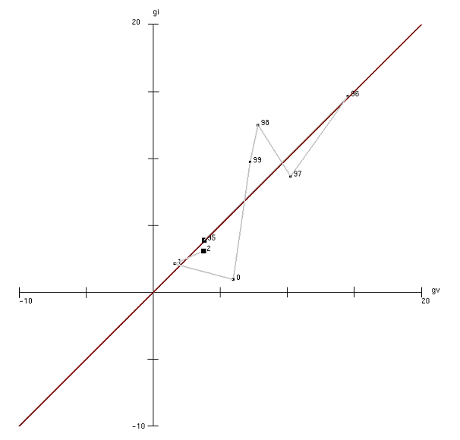

5.5 – 2002-2005: the beginning of a new (minor or major) cycle ?

In the crossover from the third to the fourth (and for us, last) phase there was a clear structural shift into the innovation space. It coincides with the beginning of the Lula’s Presidence. We do not have much data though, thus we can only surmise that has been happening, and hence what might be going on now.

The phase saw the growth of exports and sizable current account surpluses emerge. The better terms of trade linked to the high and rising prices of commodities, of which the country is a major exporter, made it possible for exports to increase even at the time of a steadily appreciating currency. Favorable external factors were not sufficiently strong for aggregate output to grow at a rapid pace. Both fiscal and monetary policies were restrictive from the standpoint of aggregate demand. Indeed, the rate of investment was lower than in the 1980s (Graph 2).

Nevertheless, productivity growth was even more impressive, configuring (as shown by Graph 7), a classroom case of growth spurred by innovation. According to Castro (2008), increase in innovative capacity, with relatively low levels of investment, arose as a response to the need to compete in international markets in an environment of strong currency and high domestic real interest rates. Firms that had survived the long period of slow growth, would have become stronger and more creative, and so better prepared to face competition. Projects that had been dormient would have been drawn out of their drawers, to put it with Castro (op.cit).

However, deliberately high real interest rates were decisive in delaying a substantial part of investment in latest-generation machinery and equipment. An important consequence of the slow pace of (absolute and per capita) investment coupled with the time lasting currency appreciation was the pronounced loss of relative weight of the transformation industry in GDP. Besides, the value added of the industrial sector increasingly concentrated into few sectors (as, in 2005, 4 sectors alone of 24 were responsible for 50% of the value added of manufacturing industry). The strong currency penalized production especially in the industrial sector: discouraged exports of non-commodities by lowering their international competitiveness and spurred imports, particularly of manufactured goods. An early de-industrialization process is often mentioned to have set in, reducing the potential (rate of) growth of the economy, increasing its vulnerability to external shocks while dictating a performance more modest that it could be otherwise.

Graph 7: a new minor cycle – 2002-2005

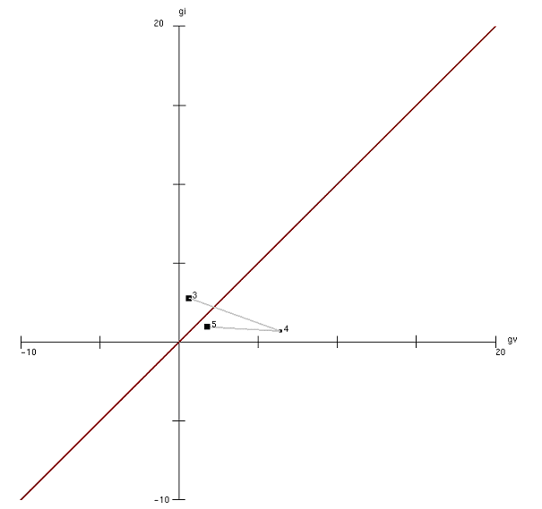

6– To conclude

The FS showed to be an interesting instrument to analize the growth pattern of the Brazilian economy as a sequence of growth paths interspersed at various degrees with instability and when deep, with episodes of structural change. In this sense we were able to distinguish different growth phases revealing specific characteristics of the dynamics of the Brazilian growth.

The dynamics of the parameters of the FS – investment per employee and producitivity – allows us to trace growth trajectories, articulated into phases, that exhibit how important fluctuations were occurring all the time. The FS reinforces the role of investment in the growth theory, showing how its unstable profile is responsible for economic fluctuations, and how economic policy and governamental interference influences the dynamics of the economic growth. In this context, the variation in the intensity of the investment per employee (gi) and producitivity (gv) variables can change the trend of growth and also explain structural changes.

The phases of growth identified in this paper showed that structural changes (1981-1994 and 1994-2002) were associated to relatively low GDP growth rates. These phases were also marked by economic policies driven to control inflation. In our view, long run expectations that guide investment decisions in capital accumulation were greatly impaired by persistant inflation and the restrictive policies to fight it. After inflation has been defeated (1994) and the economy seems to resume growth (after 2003), entering in a new growth regime (2003-2005 phase), although the threat of external constraint, which has always been a characteristics of late late comers economies is still present. Structural changes in the previous phases resulted in a loss in dynamism in manufacturing, a key sector to give a push in the production of export goods of higher unit value, a pre-condition for dependent economies to reduce their external vulnerability.

So, the foregoing analysis of the pattern of the Brazilian economy during the 1971-2005 time span, seen trough the changing dynamic relation between investment per employee and productivity, shows that the relatively low GDP performance since the 1980s can be explained by the systematic reduction in the rate of capital equipment per employee, mostly of those types of machineries that were more technologically advanced. On the other hand, growth in productivity in the 1990s, which did not go along with any comparable increase in equipment rate, did not bring the product growth rate to its historical annual level above 6% aa, as observed since the II World War until the 1980s. Innovation in the Brazilian industry during recent times has been characterized as a defensive mechanism against competion. In the same way that the Brazilian economy did not experienced more investment as in the 1970s, it did not experienced also a robust growth rate as in that period, and today it is the economy with the lowest rates of growth compared with other emerging economies.

Bibliography

Aghion, P and Howitt, P. Endogeneous Growth Theory, MIT Press, 1998.
Amado, A M, Resende, M F and Jayme Jr., F. Growth cycles in Latin American and develop countries, in 35o. Encontro Nacional de Economia, Recife, available at www.anpec.org.br/encontro.
Amendola, M and Gaffard, J. L. Out of equilibrium, Oxford Universtiy Press, 1998.
Anyul, M.P and Punzo, L.F. Structural Divergence and the Dynamics of Dualism: Lessons from Mexico before and after NAFTA. In: Mexico beyond NAFTA: Perspectives for the European Debate. Edited by Anyul, M.P. and Punzo, L.F, Routledge, 2001
Bacha, E and Bonelli, R. Uma interpretação das causas da desaceleração econômica do Brasil, Brazilian Journal of Political Economy, vol 25, no. 3 (99), July-Sepetember, 2005, pp. 163-189. An english version of the paper.[Accounting for Brazil’s growth experience: 1940-2002] is available at www.iepecdg.com.br and www.ecostrat.net/regis.html.
Barbosa Filho, N. H. International Liquidity and Growth in Brazil, CEPA Working Paper, 2001.
Böhm, B. e Punzo, L.F. Productivity-Investment Fluctuations and Structural Change, in Cycles, Growth and Structural Change: theories and empirical evidence. Edited by Lionello F. Punzo. Routledge, 2001.
Bresser-Pereira, L C. Novo desenvolvimentismo e ortodoxia convencional [New Development and the conventional ortodoxy], in Eli Diniz (org), Globalização, Estado e Desenvolvimento, FGV Editora, São Paulo, 2006.
Brida, J. G and Punzo, L F. Symbolic time series analysis and dynamics regimes, Structural Change and EconomicDynamics, vol 14, no. 2, 2003.
Castro, A.B. From Semi-stagnation to Growth in a Sino-centric Market. Brazilian Journal of Political Economy, vol 28 nº 1(109), 2008.
Castro, A.B. e Souza, F.P. A Economia Brasileira em Marcha Forçada. Editora Paz e Terra, 1985, 2004.
Dixon, R. e Thirlwall, A.P.. A Model of Regional Growth Rate differences on Kaldorian Lines. Oxford Economic Papers, vol 27, no 2, 1975.
Feijo, C A and Carvalho, F. J. C.The resiliense of high inflation and recent Brazilian failures with stabilization policies, Journal of Post Keynesian Economics, vol. 15, no. 1, 1992.
Gaffard, J L and Punzo, L F. Economic integration and cross-country convergence exercises in growth theory and empirics. Mimeo, 2005.
Harrod, R.F. An Essay in Dynamic Theory. Economic Journal, vol. 49, 1939, pp 14-33.
Hicks, sir J.Capital and time: a new austrian theory, 1973.
IBGE, National Accounts.
IBGE, Pesquisa Industrial Mensal: Produção Física e de Emprego e Salário. .
IEDI. Ocorreu uma Desindustrialização no Brasil?, mimeo, available at http://www.iedi.org.br/admin_ori/pdf/20051129_desindustrializacao.pdf, 2005, access November, 2008.
IPEADATA, Capital fixo- estoque bruto total.
Kaldor, N. A Model of Economic Growth, Economic Journal, 1957.
Kaldor, N. & Mirrlees, J.A. A New Model of Economic Growth, Review of Economic Studies, vol. 29, 1961-1962.
León-Ledesma, M.A. and Thirlwall, A. P. The Endogeneity of Natural Rate of Growth. Cambridge Journal of Economics, vol 26, 2002.
Libânio, G. Aggregate Demand and the Endogeneity of the Natural Rate of Growth: Evidence from Latin American Economies. Encontro de Economia Política da SEP, 2008.
Morandi, L and Reis, E J. Estoque de capital fixo no Brasil: 1950-2002, 32o. Encontro Nacional de Economia, João Pessoa, 2004, available at http://www.anpec.org.br/encontro2004/artigos/A04A042.pdf, acess November 30, 2008.
Nassif, A. Há evidência de desindustrialização no Brasil? {Is there evidences of desindustrialization in Brazil?], Brazilian Journal of Political Economy, vol 28, no. 1 (109), January-March, 2008.
New Palgrave, the: A dictionary of economics. Edited by Eatwell, J; Milgate, M; Nesman, P. The MacMillan Press Limited, 1994
Palma, J. G. Quatro fontes de desindustrialização e um novo conceito de doença holandesa [Four sources of deindustrialization and a new concept of Dutch Disease], paper prepared to the Conference on Industrialization, Desindustrialization and Development, FIESP and IEDI, August, 2005, available at http://www.fiesp.com.br/download/publicacoes_economia/jose_gabriel_palma.pdf, access November 29th, 2008.
Punzo, L.F. Towards a disequilibrium theory of structural dynamics: Goodwin’s contributions, Structural Change and EconomicDynamics, vol. 17, no. 4. 2006.
Serra. J. Ciclos e mudanças estruturais na economia brasileira do apos guerra, Review of Political Economy, vol 2/2, no. 6, 1982.
Thirlwall, A. P. Trade, the Balance of Payments and Exchange Rate Policy in Developing Countries. Cheltenham: Edward Elgar, 2003.
Thirlwall, A.P. The Balance of Payments Constraint as an Explanation of International Growth Rates. Banca Nazionale del Lavoro Quarterly Review, March, 1979.

For a long term analysis of Brazilian experience of growth and a review of the hot debate between opposing interpretations, see Bresser-Pereira (2006).
The authors quote several recent publications manifesting a similar concern. Bresser-Pereira (2006 ch. 2 p. 63) remarks: “While between 1930 and 1980 no other country grew more rapidily [in terms of GDP] than Brazil, since 1980, or 1994, Brazil is one of the economies that grew less”.
Nevertheless, although growth rates were consistently lower after 1980s, volatility remained of a comparable size. Values for standard deviations of GDP growth rates of years 1945-1980 and 1981-2007, are the same (3.17), in spite of the fact that the average level of the rate of growth was reduced to 1/3 (from 6.4% aa of 1945-1980 to 2.4% aa of 1981-2007).
Bacha and Bonelli (op.cit, p. 180), for the 1940-2002 period, define six distinctive phases four of which refer to our time horizon: after the first one with the war-end and post-war prosperity (1942-1952); and the second, associated with Kubitscheck era and its aftermath (1952-1964); they identify a Brazilian authoritarian ‘miracle’(1964-1974); a period of external shocks and the waning of the military control (1974-1984); followed by the (1984-1993) phase of hyperinflation and finally by the era of the Plano Real (1993-2002). Castro (2008) periodization has: 1980-1994, with instability marked by a “ blend of the so-called debt crisis with high inflation “; the 1994-1998, characterized by macroeconomic stabilization induced by the Plano Real; the phase 1999-2003 marked by the transition to free floating exchange rate policy and structural reforms, but still dominated by high uncertainty and thus slow growth; and finally the time period from 2004 onwards where the question is why the Brazilian economy remained in a semi-stagnation. On the other hand, to account for the evolution of the reflection upon Brazil’s development model, Bresser-Pereira (op.cit) has three phases since 1930, of which two since 1964.
The cristal clear version of such prediction is in the neoclassical theory, stating that in the steady state eventually to be realized, the rate of growth of the economy depends only on the population rate of growth and of the technical progress. It is this clarity that made its fortune as a theory and as a set of econometrically falsifiable propositions.
Usually, this prediction is associated with the neoclassical theory, which states the existence of a globally attracting path. However, the same prediction is implicitly assumed, at least as a local property, by all growth theories that we know of.
Transitory dynamics is the trajectory towards the steady state attractor.
Kaldor (1957); Kaldor-Mirrlees (1961-1962).
Harrodian behavior is generalized to a set of steady state trajectorys. See Harrod (1939).
Just as an example of another definition of structural change we recall that in the kaldorian view structural change is observed when there is an alteration in the sectorial composition of the industry coupled with the degree of technological intensity. These changes would be captured by demand elasticity of exports and imports. See Dixon and Thirlwall (1975), Thilwall (1979) and New Palgrave, (1994)
The most elementary trajectory is an equilibrium path, i.e. a state in the FS that repeats itself unless disturbed from outside On the other hand, when the partition coincides with the FS itself, we have the notion that there is a unique interpretive model for growth.
FS as the state space of the mathematical model of multi-regime dynamics is a discrete space populated by models/regimes.
The statistical series used were the real Capital Stock rate of growth, from IPEA, Physical Industrial Production index, and Industrial Employment index, both from the Brazilian Statistical Office (IBGE). Our choice for the industrial production index is due to the fact that the longest employment data series available is to the industrial sector (manufacturing and mining), starting in the 1970s. In this sense, industrial production and employment come from the Montlhy Industrial Surveys of IBGE. As observed in Graph 1, the real GDP growth series follows close the industrial growth series. For Capital Stock the time series is from IPEADATA, based on Morandi and Reis (2004) methodology. We do not use Gross Fixed Capital Formation data from the National Accounts as a proxy for investment, due to many revisions in the methodology along the time: 1985, 1997 and 2007.
We define as minor a cycle that does not include a regime switch.
This type of effects are called construction and utilization cycles, after Hicks (1973), or neo Austrian cycles, see Amendola and Gaffard (1998).
As an illustration, the share of Brazilian manufacturing industry in GDP (around 18%) is close to the value observed in developed countries, whose per capita income is in average 7 times the Brazilian’s. This is an evidence of the premature character of the de-industrialization process of the Brazilian economy (IEDI, 2005).
Brazil’s currency, the Real, later appreciated even more: in December 2006 and 2007, the exchange rate against the dollar was R$ 2.16 and R$ 1.77 respectively (Brazilian Central Bank Bulletin, purchase rate, monthly average).
For a debate around this subject in Brazil, see Palma, 2005, IEDI, 2005, Nassif, 2008, among others.
Castro (op. cit) argues that in spite of years of slow growth, most of the Brazilian industry is still quite competitive and, on the whole, it is well diversified. The author’s optimism leads to argue, convincingly, that the Brazilian economy is indeed specialized in the production of commodites, but many of them incorporate high technology, and Brazil is a technology-leader in many production processes of commodities transformation.
Between 1990-2003 the annual rate of growth of the Brazilian manufacturing industry was 1.6%aa, while in China this rate was 11.7%; in Korea 7.4% and in India 6.5%. (IEDI, 2005, pp. 2 and 3, based on OECD data bases).

